

Housing Selling Price Prediction

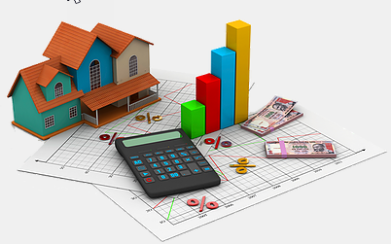



Submitted by:

Manoj.I.V

**ACKNOWLEDGMENT**

This includes mentioning of all the references, research papers, data sources, professionals and other resources that helped you and guided you in completion of the project.

INTRODUCTION

* Business Problem Framing

Describe the business problem and how this problem can be related to the real world.

Answer: The business problem is to predict the selling price of the houses. In real world many parameters like area, connectivity, quality of building materials etc. comes in to consideration. In the dataset the columns in train is Index(['Id', 'MSSubClass', 'MSZoning', 'LotFrontage', 'LotArea', 'Street', 'Alley', 'LotShape', 'LandContour', 'Utilities', 'LotConfig', 'LandSlope', 'Neighborhood', 'Condition1', 'Condition2', 'BldgType', 'HouseStyle', 'OverallQual', 'OverallCond', 'YearBuilt', 'YearRemodAdd', 'RoofStyle', 'RoofMatl', 'Exterior1st', 'Exterior2nd', 'MasVnrType', 'MasVnrArea', 'ExterQual', 'ExterCond', 'Foundation', 'BsmtQual', 'BsmtCond', 'BsmtExposure', 'BsmtFinType1', 'BsmtFinSF1', 'BsmtFinType2', 'BsmtFinSF2', 'BsmtUnfSF', 'TotalBsmtSF', 'Heating','HeatingQC', 'CentralAir', 'Electrical', '1stFlrSF', '2ndFlrSF','LowQualFinSF', 'GrLivArea', 'BsmtFullBath', 'BsmtHalfBath', 'FullBath', 'HalfBath', 'BedroomAbvGr', 'KitchenAbvGr', 'KitchenQual', 'TotRmsAbvGrd', 'Functional', 'Fireplaces', 'FireplaceQu', 'GarageType', 'GarageYrBlt', 'GarageFinish', 'GarageCars', 'GarageArea', 'GarageQual', 'GarageCond', 'PavedDrive', 'WoodDeckSF', 'OpenPorchSF', 'EnclosedPorch', '3SsnPorch', 'ScreenPorch', 'PoolArea', 'PoolQC', 'Fence', 'MiscFeature', 'MiscVal', 'MoSold', 'YrSold', 'SaleType', 'SaleCondition', 'SalePrice']. Every column is an accessory for the complete home. Each component has its own use.

* Conceptual Background of the Domain Problem

Describe the domain related concepts that you think will be useful for better understanding of the project.

Answer: Basically we should know the people requirements as requirement of different people are different. The design and comfort of the house is one part, next comes the location of the house, House Style, heating system, garage placement in the house, number of rooms etc. There are many other accessories such as kitchen quality, Functional, Fireplaces, Fireplace, Quality etc.

* Review of Literature

This is a comprehensive summary of the research done on the topic. The review should enumerate, describe, summarize, evaluate and clarify the research done.

Answer: As each column has a different accessory of the house it has to be analysed and prioritized based on the cost. This helps in the ordinal encoding of the machine learning model.

* Motivation for the Problem Undertaken

Describe your objective behind to make this project, this domain and what is the motivation behind.

Answer: The motivation is to build a predictive model that can predict selling price of the house including all the accessories. The total of 80 columns have been assigned having different view of the different accessories. Basically it depends on the public choice for choosing a house.

**Analytical Problem Framing**

* Mathematical/ Analytical Modeling of the Problem

Describe the mathematical, statistical and analytics modelling done during this project along with the proper justification.

* Data Sources and their formats

What are the data sources, their origins, their formats and other details that you find necessary? They can be described here. Provide a proper data description. You can also add a snapshot of the data.

Answer: The data can be taken by a survey of Real Estate Company, open source websites like Kaggel etc. The data is in the form of .csv file it may also be in .json or Excel files. Currently the data was provided in terms of .csv files. There is training file with 1168 columns and 81 rows. There is a test file with 292 columns and 80 rows. The below shows the column list.

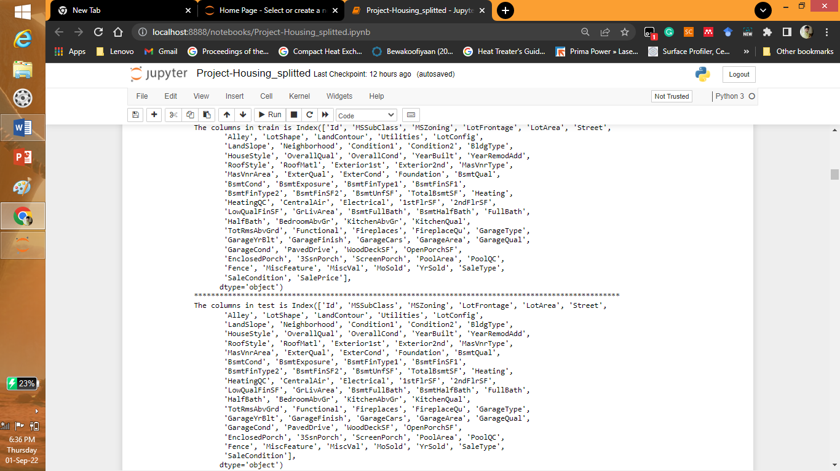

Finding type of the data:

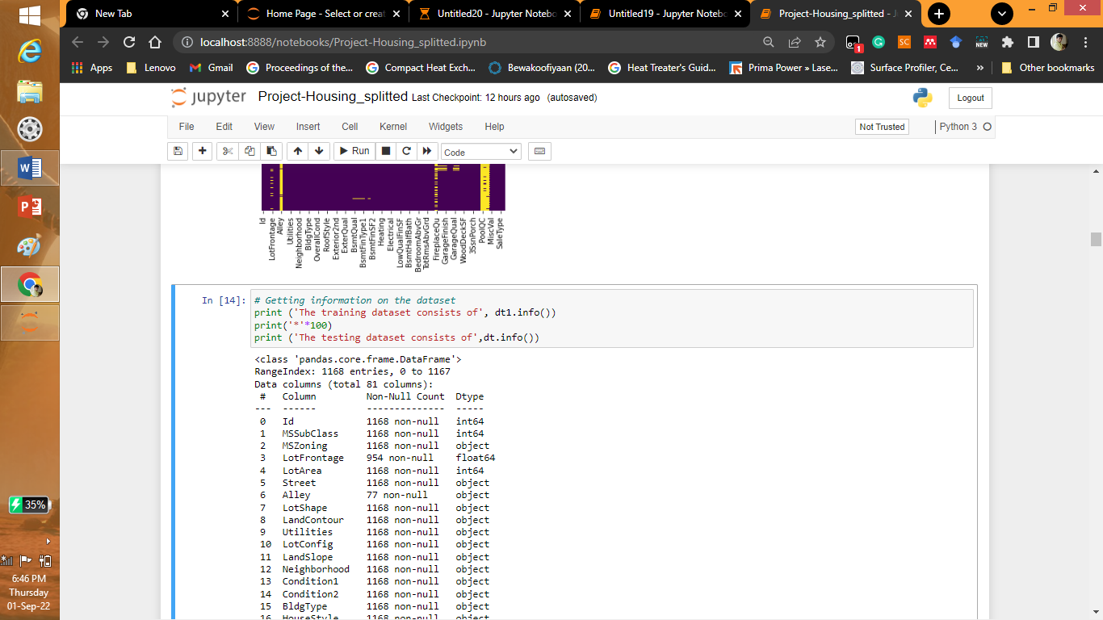

<class 'pandas.core.frame.DataFrame'>

RangeIndex: 1168 entries, 0 to 1167

Data columns (total 81 columns):

# Column Non-Null Count Dtype

--- ------ -------------- -----

0 Id 1168 non-null int64

1 MSSubClass 1168 non-null int64

2 MSZoning 1168 non-null object

3 LotFrontage 954 non-null float64

4 LotArea 1168 non-null int64

5 Street 1168 non-null object

6 Alley 77 non-null object

7 LotShape 1168 non-null object

8 LandContour 1168 non-null object

9 Utilities 1168 non-null object

10 LotConfig 1168 non-null object

11 LandSlope 1168 non-null object

12 Neighborhood 1168 non-null object

13 Condition1 1168 non-null object

14 Condition2 1168 non-null object

15 BldgType 1168 non-null object

16 HouseStyle 1168 non-null object

17 OverallQual 1168 non-null int64

18 OverallCond 1168 non-null int64

19 YearBuilt 1168 non-null int64

20 YearRemodAdd 1168 non-null int64

21 RoofStyle 1168 non-null object

22 RoofMatl 1168 non-null object

23 Exterior1st 1168 non-null object

24 Exterior2nd 1168 non-null object

25 MasVnrType 1161 non-null object

26 MasVnrArea 1161 non-null float64

27 ExterQual 1168 non-null object

28 ExterCond 1168 non-null object

29 Foundation 1168 non-null object

30 BsmtQual 1138 non-null object

31 BsmtCond 1138 non-null object

32 BsmtExposure 1137 non-null object

33 BsmtFinType1 1138 non-null object

34 BsmtFinSF1 1168 non-null int64

35 BsmtFinType2 1137 non-null object

36 BsmtFinSF2 1168 non-null int64

37 BsmtUnfSF 1168 non-null int64

38 TotalBsmtSF 1168 non-null int64

39 Heating 1168 non-null object

40 HeatingQC 1168 non-null object

41 CentralAir 1168 non-null object

42 Electrical 1168 non-null object

43 1stFlrSF 1168 non-null int64

44 2ndFlrSF 1168 non-null int64

45 LowQualFinSF 1168 non-null int64

46 GrLivArea 1168 non-null int64

47 BsmtFullBath 1168 non-null int64

48 BsmtHalfBath 1168 non-null int64

49 FullBath 1168 non-null int64

50 HalfBath 1168 non-null int64

51 BedroomAbvGr 1168 non-null int64

52 KitchenAbvGr 1168 non-null int64

53 KitchenQual 1168 non-null object

54 TotRmsAbvGrd 1168 non-null int64

55 Functional 1168 non-null object

56 Fireplaces 1168 non-null int64

57 FireplaceQu 617 non-null object

58 GarageType 1104 non-null object

59 GarageYrBlt 1104 non-null float64

60 GarageFinish 1104 non-null object

61 GarageCars 1168 non-null int64

62 GarageArea 1168 non-null int64

63 GarageQual 1104 non-null object

64 GarageCond 1104 non-null object

65 PavedDrive 1168 non-null object

66 WoodDeckSF 1168 non-null int64

67 OpenPorchSF 1168 non-null int64

68 EnclosedPorch 1168 non-null int64

69 3SsnPorch 1168 non-null int64

70 ScreenPorch 1168 non-null int64

71 PoolArea 1168 non-null int64

72 PoolQC 7 non-null object

73 Fence 237 non-null object

74 MiscFeature 44 non-null object

75 MiscVal 1168 non-null int64

76 MoSold 1168 non-null int64

77 YrSold 1168 non-null int64

78 SaleType 1168 non-null object

79 SaleCondition 1168 non-null object

80 SalePrice 1168 non-null int64

dtypes: float64(3), int64(35), object(43)

memory usage: 739.2+ KB

The training dataset consists of None

****************************************************************************************************

<class 'pandas.core.frame.DataFrame'>

RangeIndex: 292 entries, 0 to 291

Data columns (total 80 columns):

# Column Non-Null Count Dtype

--- ------ -------------- -----

0 Id 292 non-null int64

1 MSSubClass 292 non-null int64

2 MSZoning 292 non-null object

3 LotFrontage 247 non-null float64

4 LotArea 292 non-null int64

5 Street 292 non-null object

6 Alley 14 non-null object

7 LotShape 292 non-null object

8 LandContour 292 non-null object

9 Utilities 292 non-null object

10 LotConfig 292 non-null object

11 LandSlope 292 non-null object

12 Neighborhood 292 non-null object

13 Condition1 292 non-null object

14 Condition2 292 non-null object

15 BldgType 292 non-null object

16 HouseStyle 292 non-null object

17 OverallQual 292 non-null int64

18 OverallCond 292 non-null int64

19 YearBuilt 292 non-null int64

20 YearRemodAdd 292 non-null int64

21 RoofStyle 292 non-null object

22 RoofMatl 292 non-null object

23 Exterior1st 292 non-null object

24 Exterior2nd 292 non-null object

25 MasVnrType 291 non-null object

26 MasVnrArea 291 non-null float64

27 ExterQual 292 non-null object

28 ExterCond 292 non-null object

29 Foundation 292 non-null object

30 BsmtQual 285 non-null object

31 BsmtCond 285 non-null object

32 BsmtExposure 285 non-null object

33 BsmtFinType1 285 non-null object

34 BsmtFinSF1 292 non-null int64

35 BsmtFinType2 285 non-null object

36 BsmtFinSF2 292 non-null int64

37 BsmtUnfSF 292 non-null int64

38 TotalBsmtSF 292 non-null int64

39 Heating 292 non-null object

40 HeatingQC 292 non-null object

41 CentralAir 292 non-null object

42 Electrical 291 non-null object

43 1stFlrSF 292 non-null int64

44 2ndFlrSF 292 non-null int64

45 LowQualFinSF 292 non-null int64

46 GrLivArea 292 non-null int64

47 BsmtFullBath 292 non-null int64

48 BsmtHalfBath 292 non-null int64

49 FullBath 292 non-null int64

50 HalfBath 292 non-null int64

51 BedroomAbvGr 292 non-null int64

52 KitchenAbvGr 292 non-null int64

53 KitchenQual 292 non-null object

54 TotRmsAbvGrd 292 non-null int64

55 Functional 292 non-null object

56 Fireplaces 292 non-null int64

57 FireplaceQu 153 non-null object

58 GarageType 275 non-null object

59 GarageYrBlt 275 non-null float64

60 GarageFinish 275 non-null object

61 GarageCars 292 non-null int64

62 GarageArea 292 non-null int64

63 GarageQual 275 non-null object

64 GarageCond 275 non-null object

65 PavedDrive 292 non-null object

66 WoodDeckSF 292 non-null int64

67 OpenPorchSF 292 non-null int64

68 EnclosedPorch 292 non-null int64

69 3SsnPorch 292 non-null int64

70 ScreenPorch 292 non-null int64

71 PoolArea 292 non-null int64

72 PoolQC 0 non-null float64

73 Fence 44 non-null object

74 MiscFeature 10 non-null object

75 MiscVal 292 non-null int64

76 MoSold 292 non-null int64

77 YrSold 292 non-null int64

78 SaleType 292 non-null object

79 SaleCondition 292 non-null object

dtypes: float64(4), int64(34), object(42)

memory usage: 182.6+ KB

The testing dataset consists of NAN values:

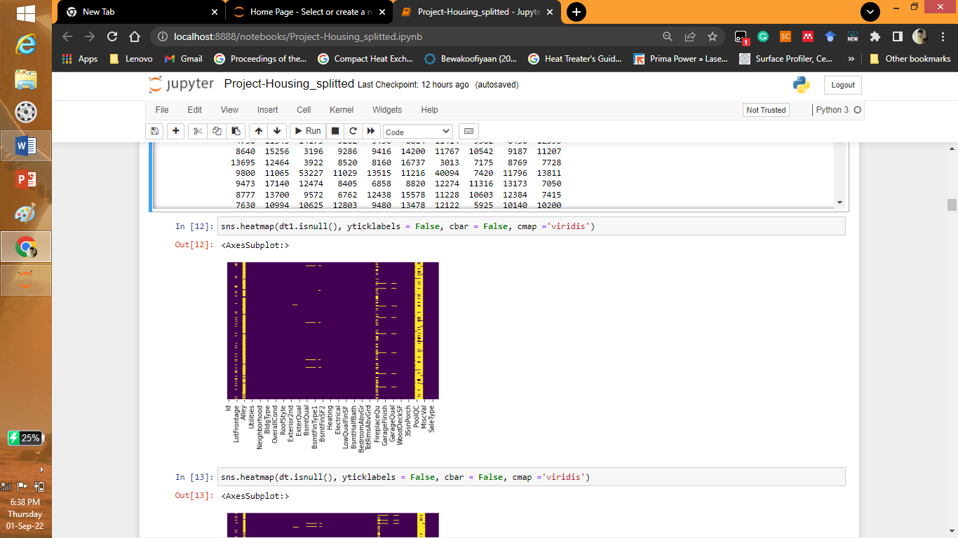

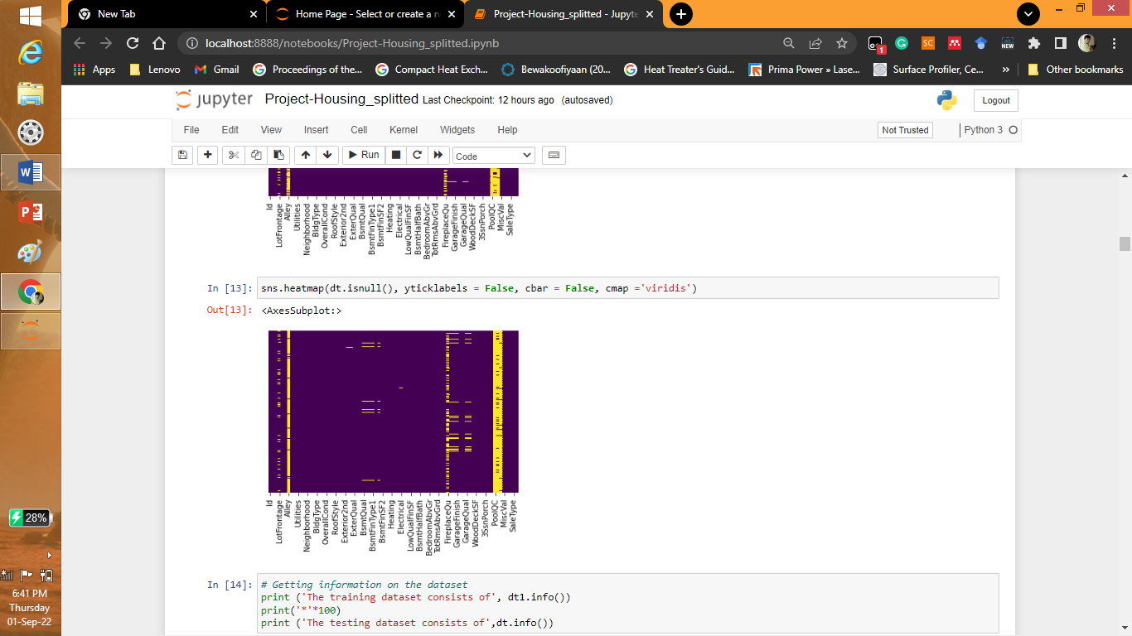

The correlation of the dataset is as follows:

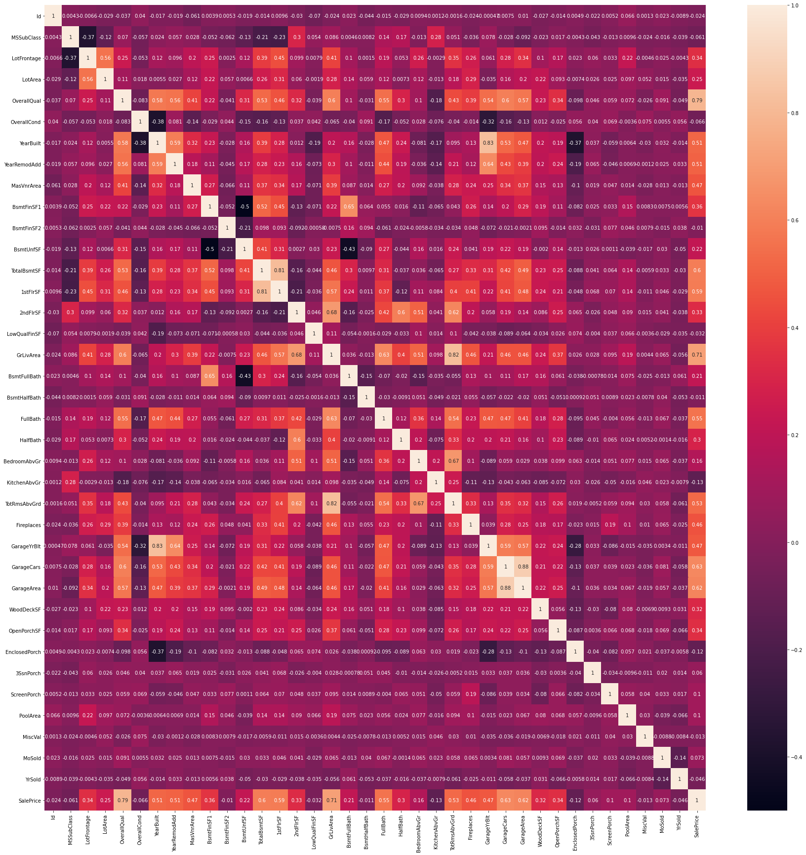

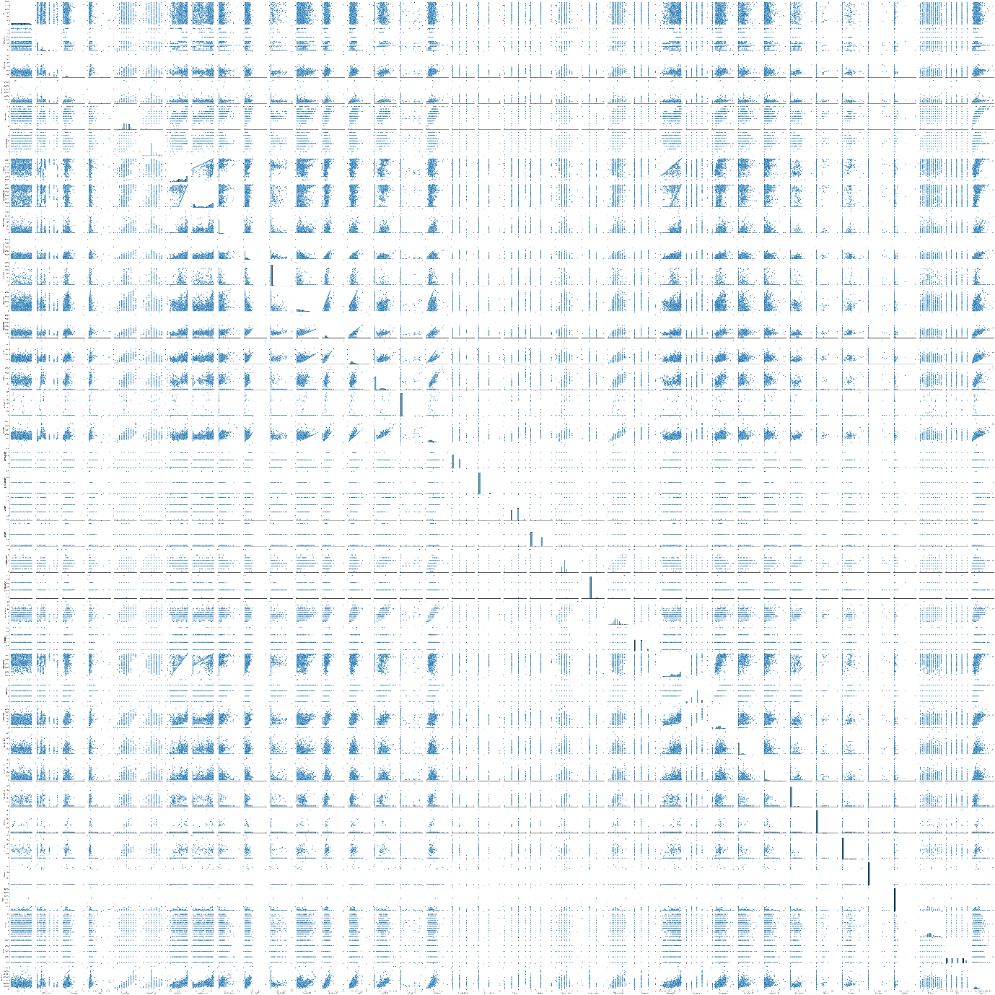

* Data Preprocessing Done

What were the steps followed for the cleaning of the data? What were the assumptions done and what were the next actions steps over that?

Answer: The BsmtQual, BsmtCond, BsmtExposure, BsmtFinType1, BsmtFinType2, FireplaceQu, GarageType, GarageFinish, GarageQual, GarageCond, Electricity have been replaced by the median. The following shows the different snapshots in the python.

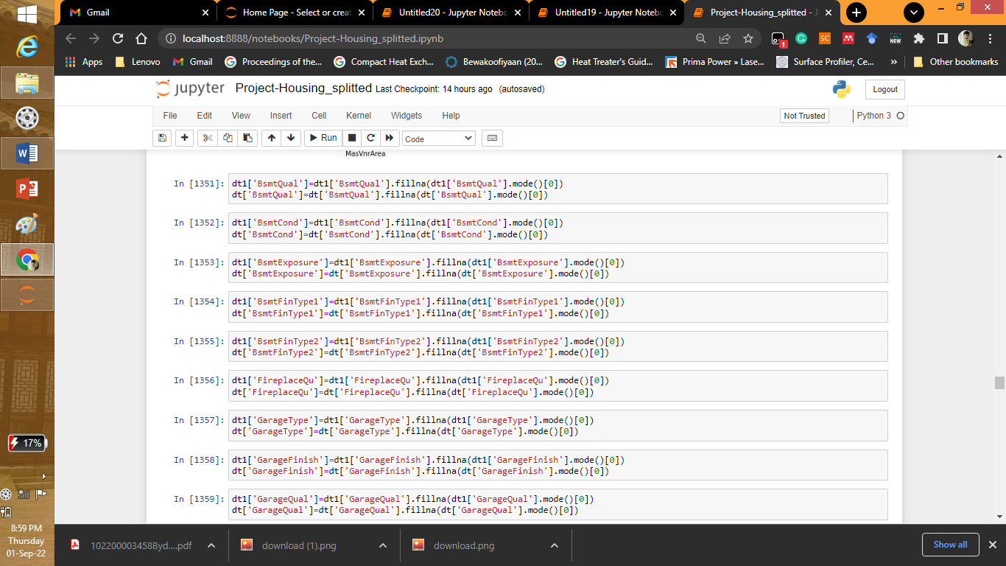

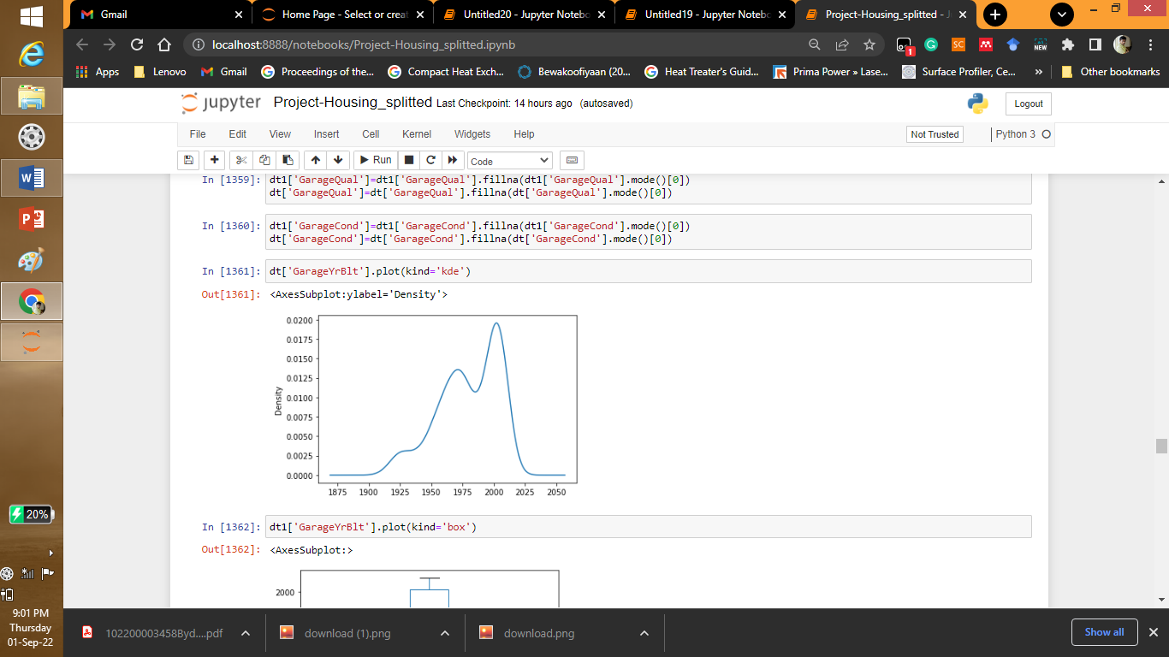

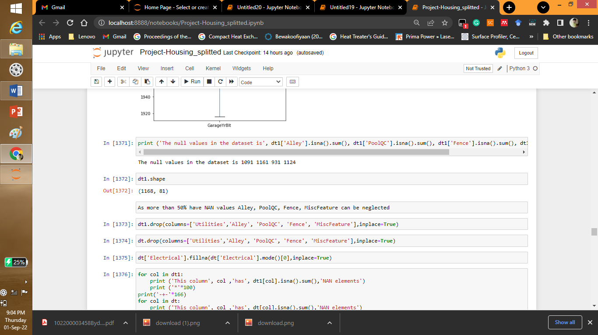

* Data Inputs- Logic- Output Relationships

Describe the relationship behind the data input, its format, the logic in between and the output. Describe how the input affects the output.

Answer: For identifying the relationship between the input and output parameters bivariate analysis was performed where each column type is compared to the selling price of the house.

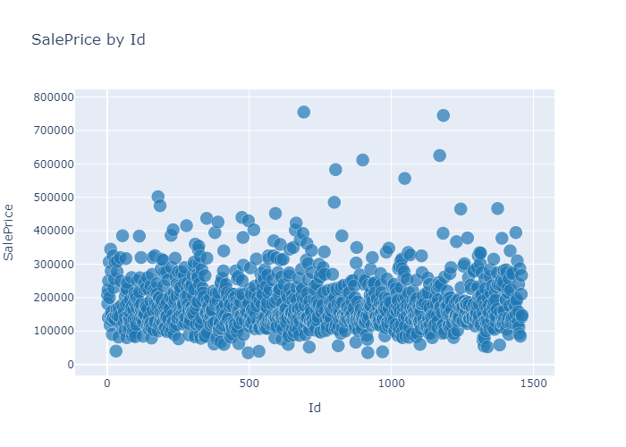

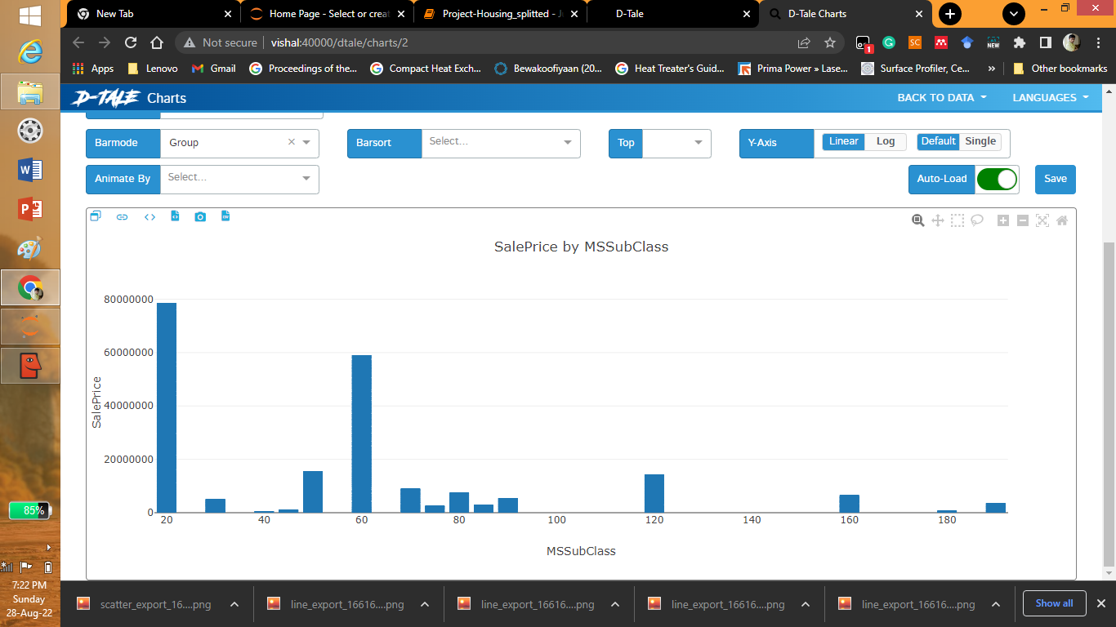

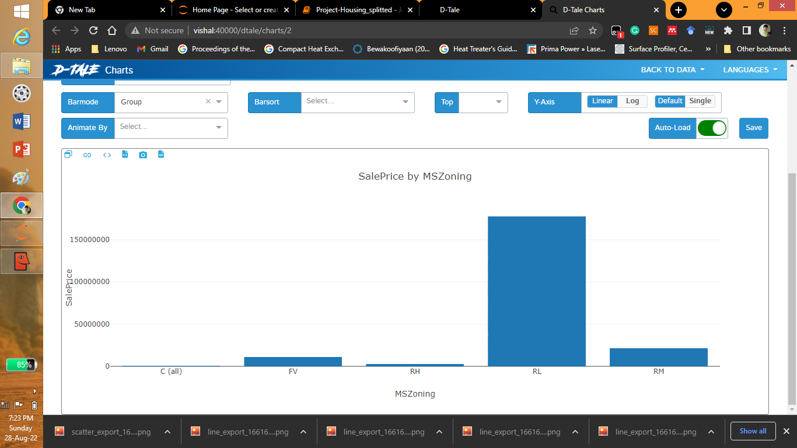

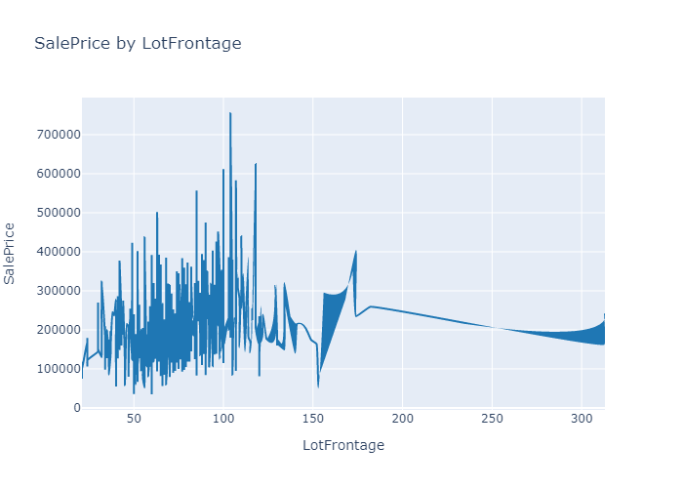

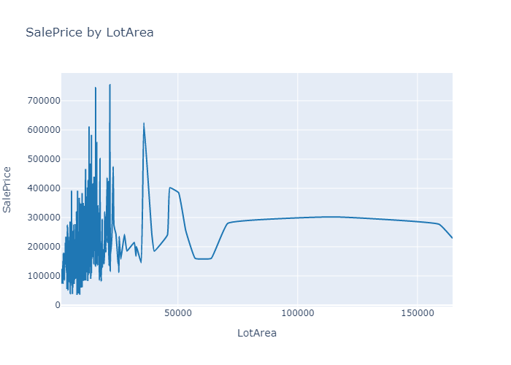

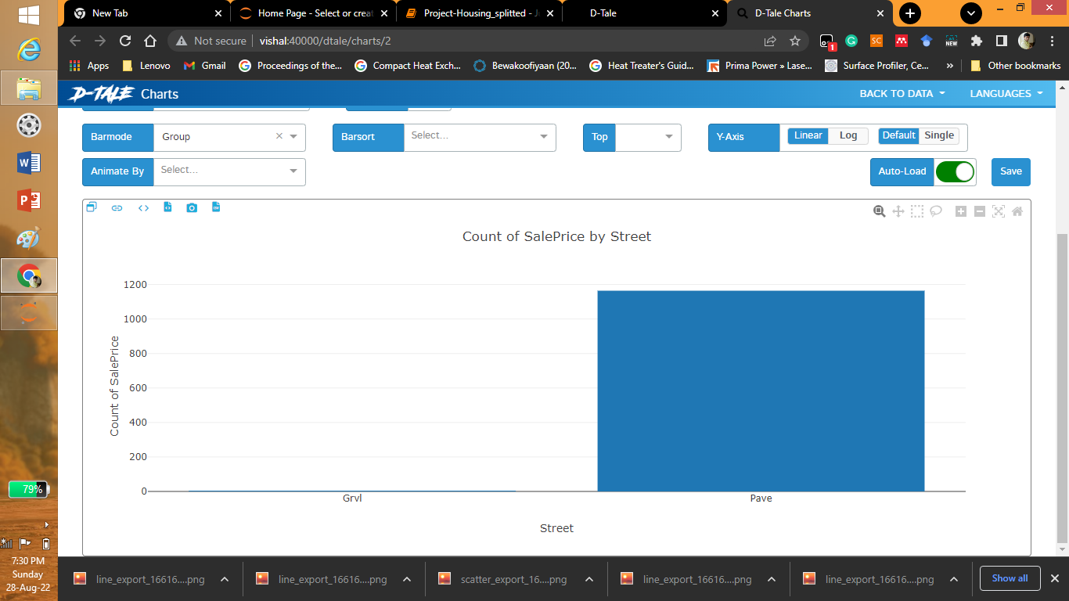

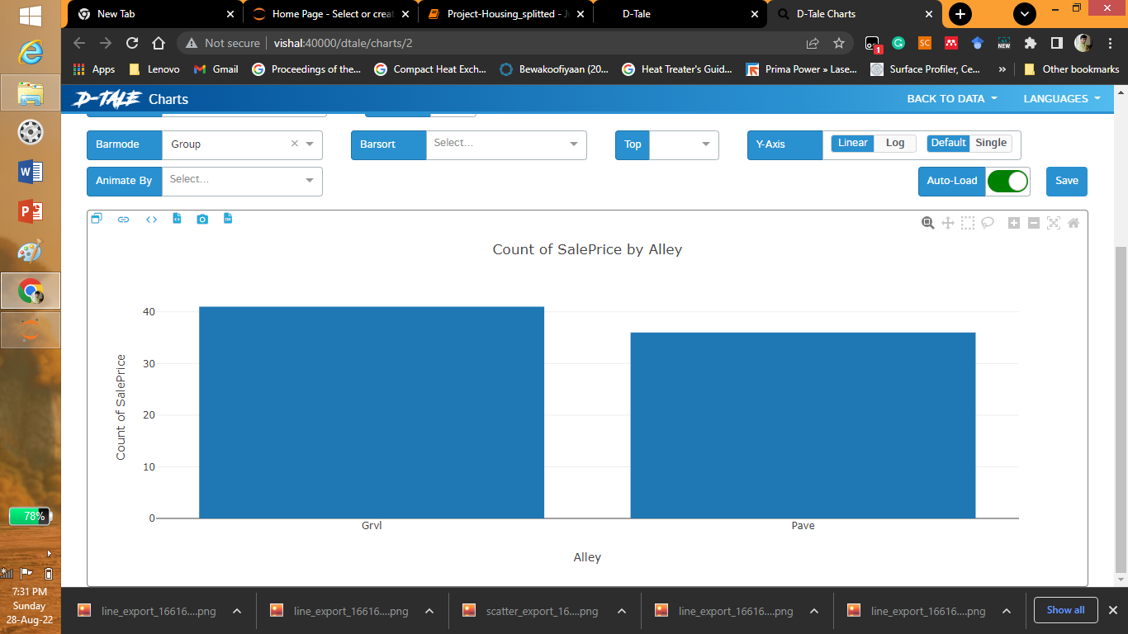

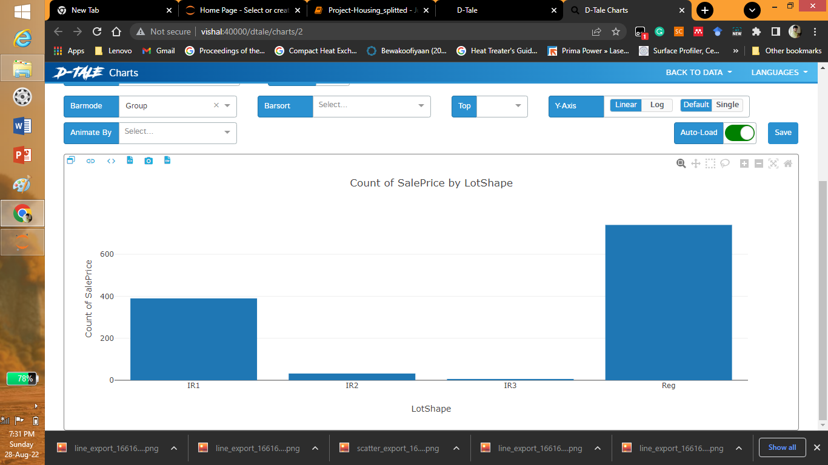

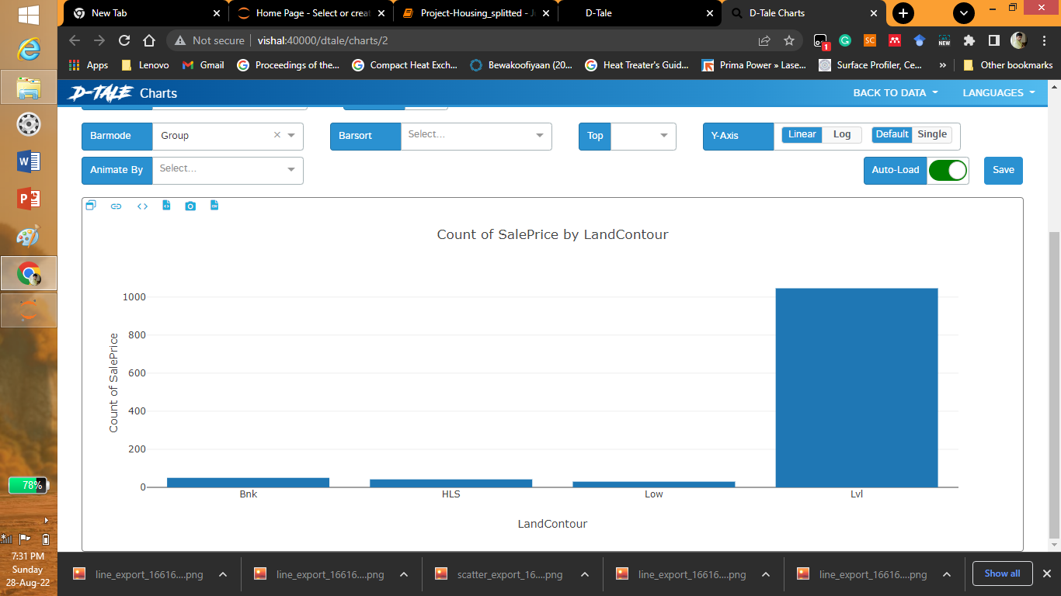

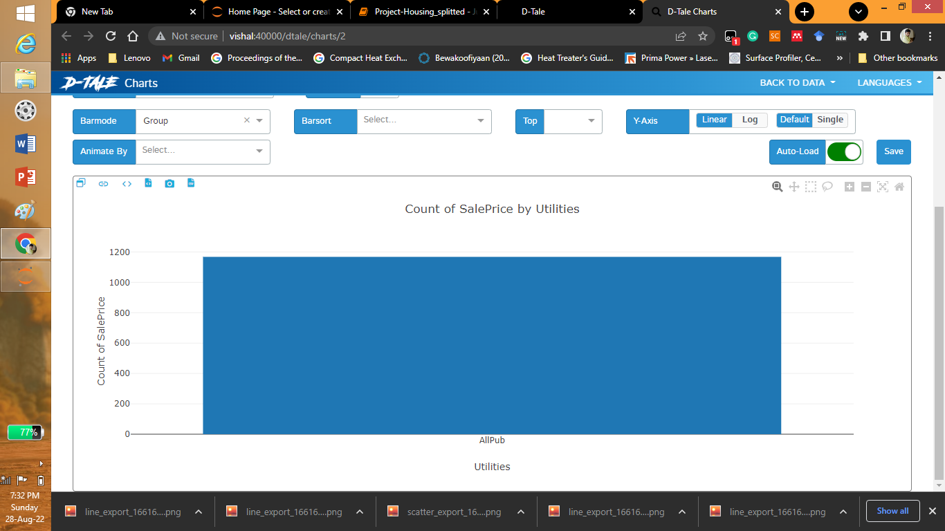

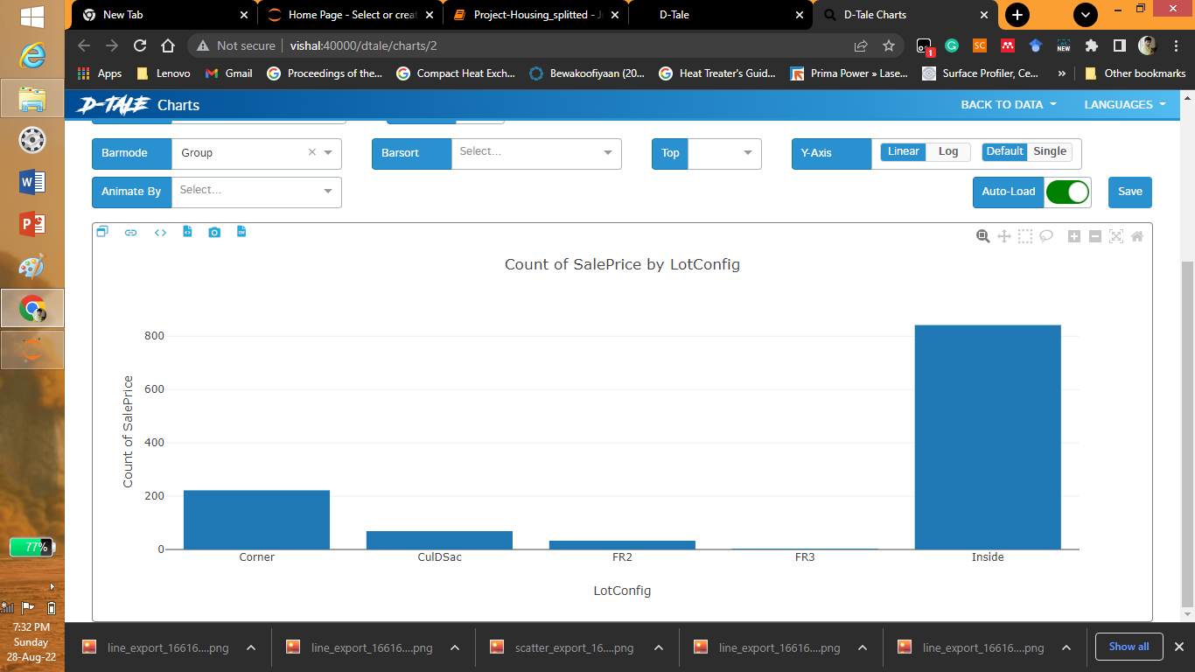

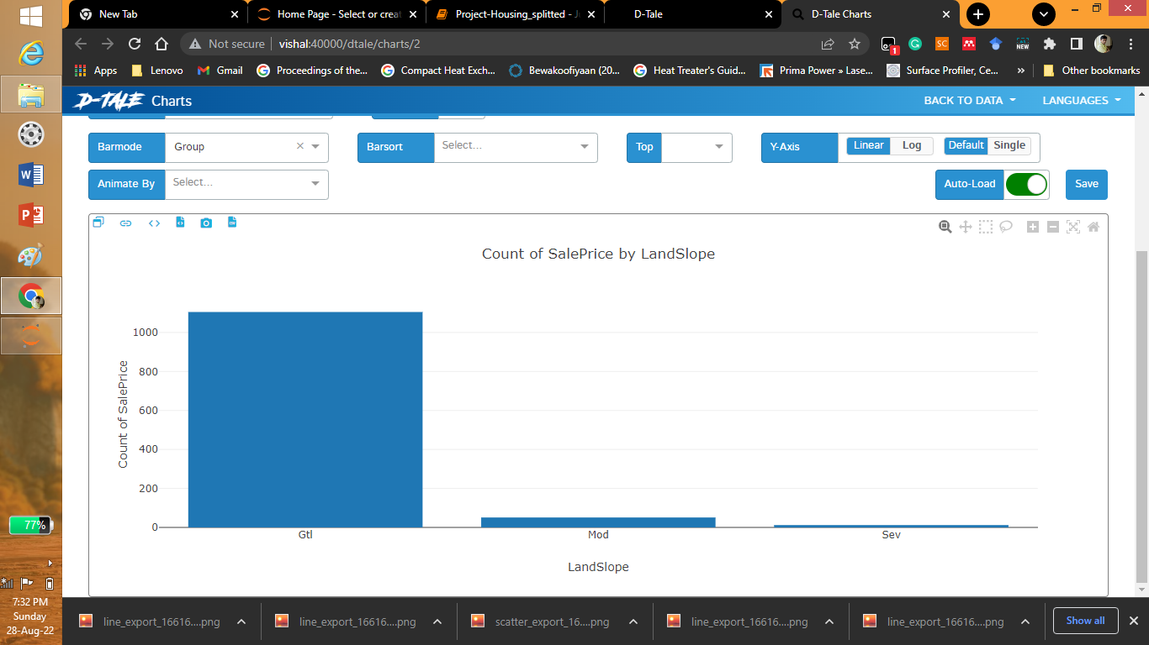

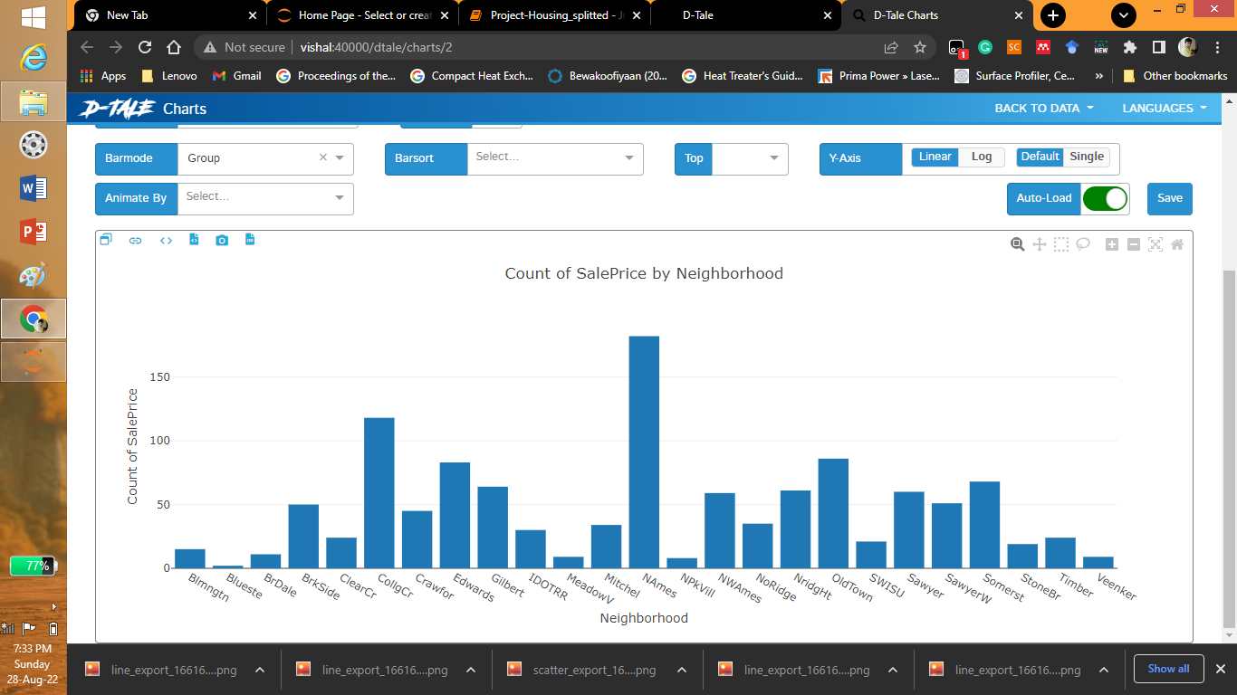

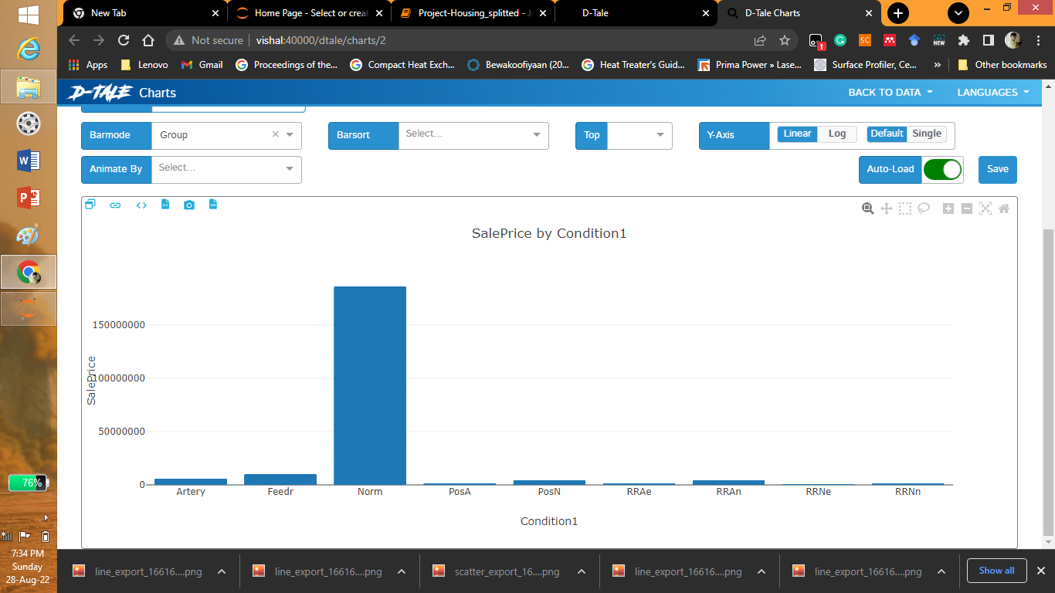

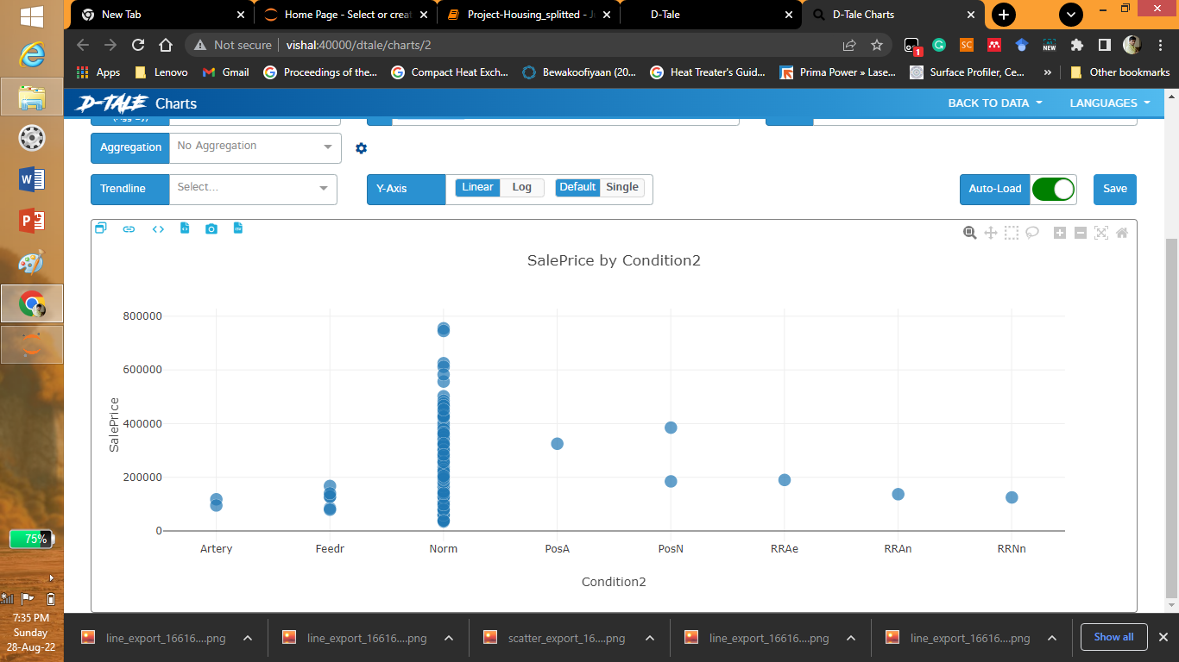

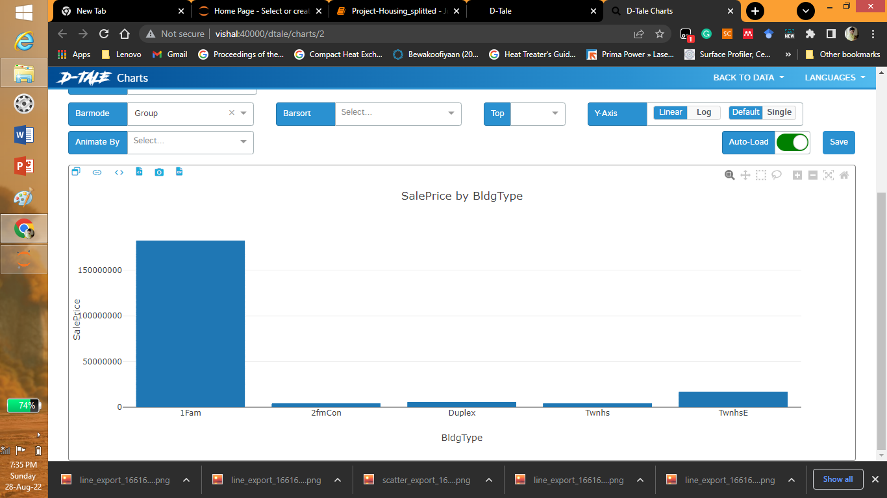

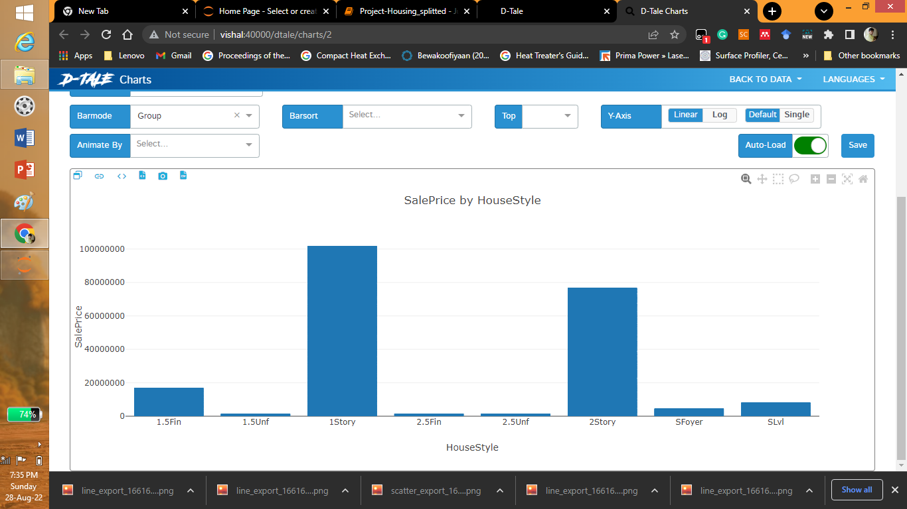

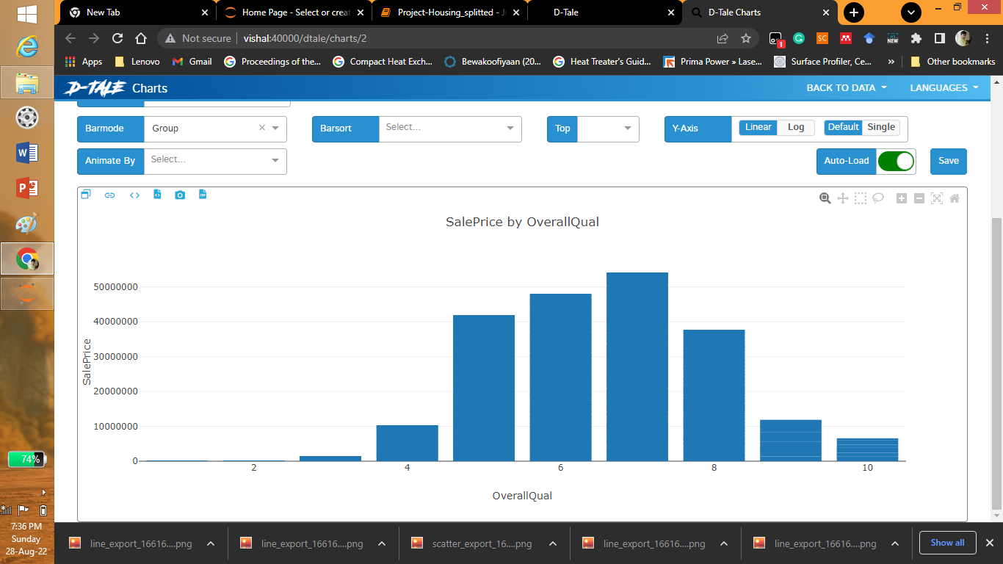

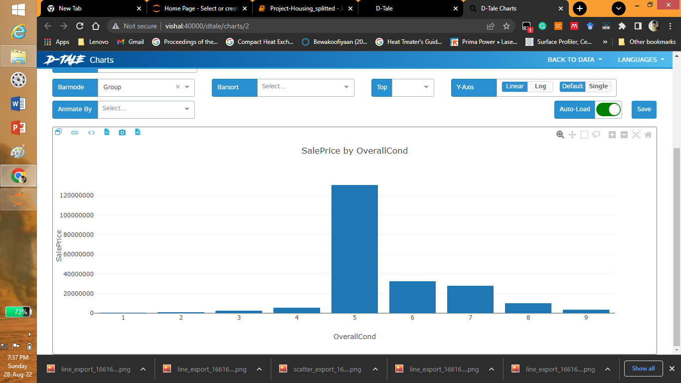

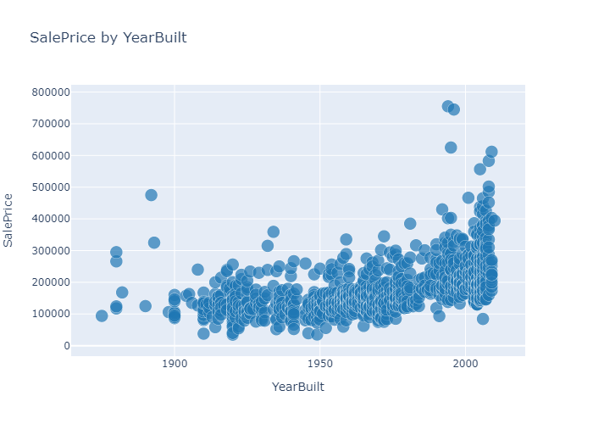

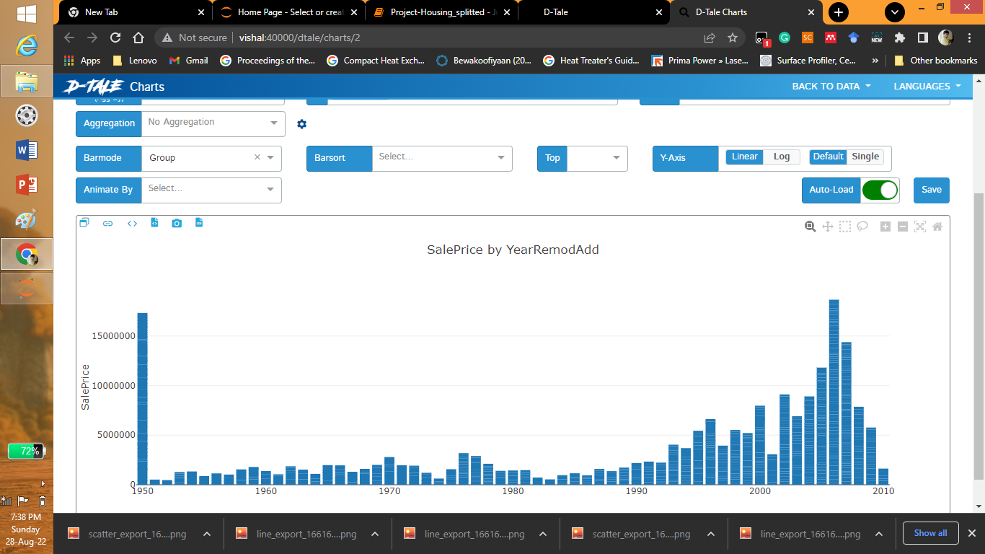

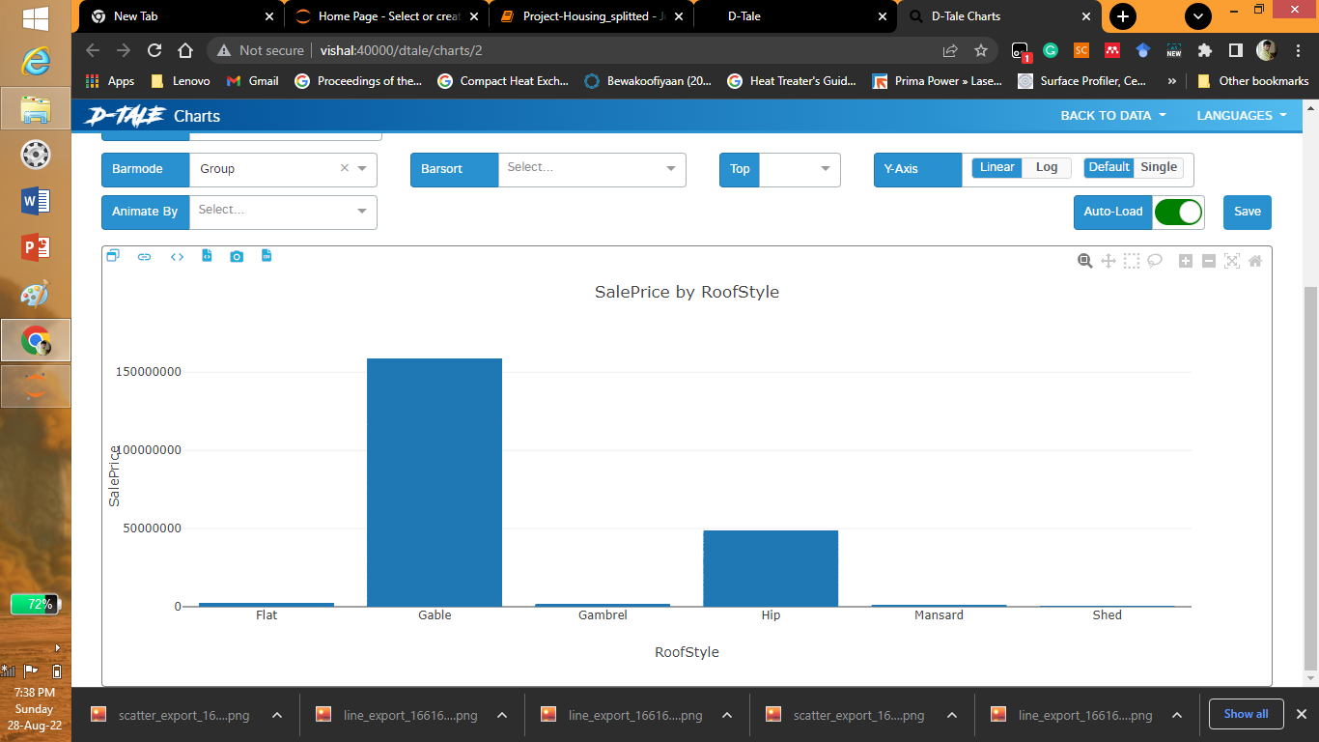

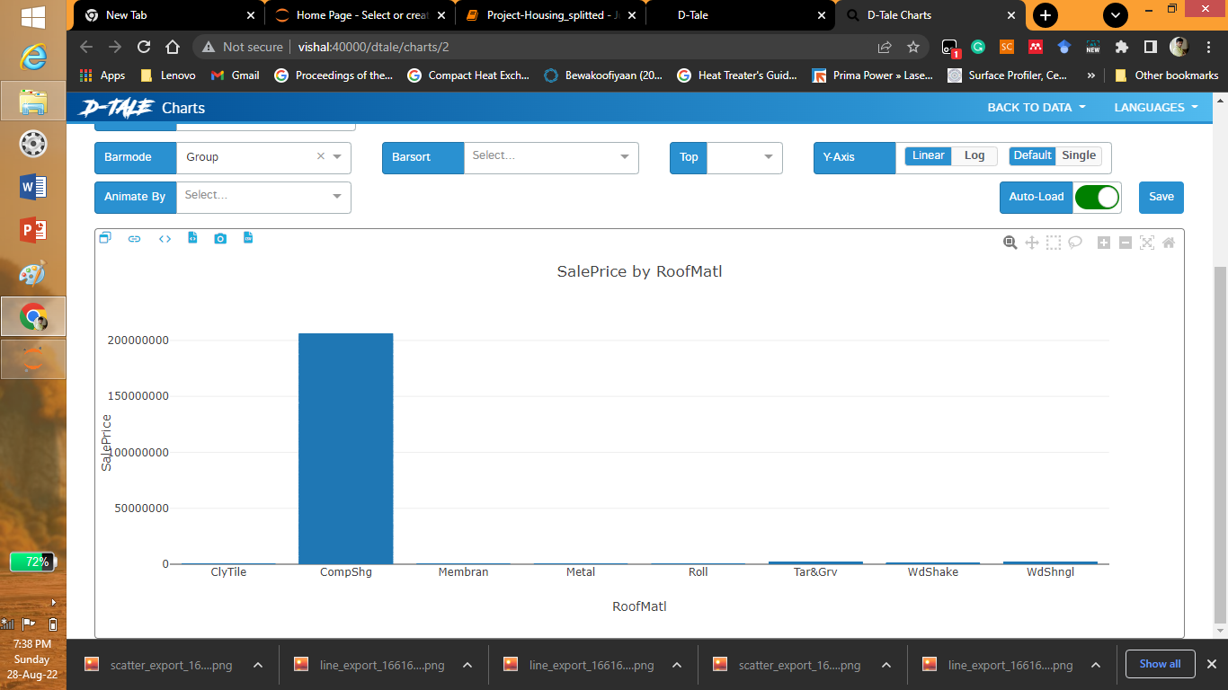

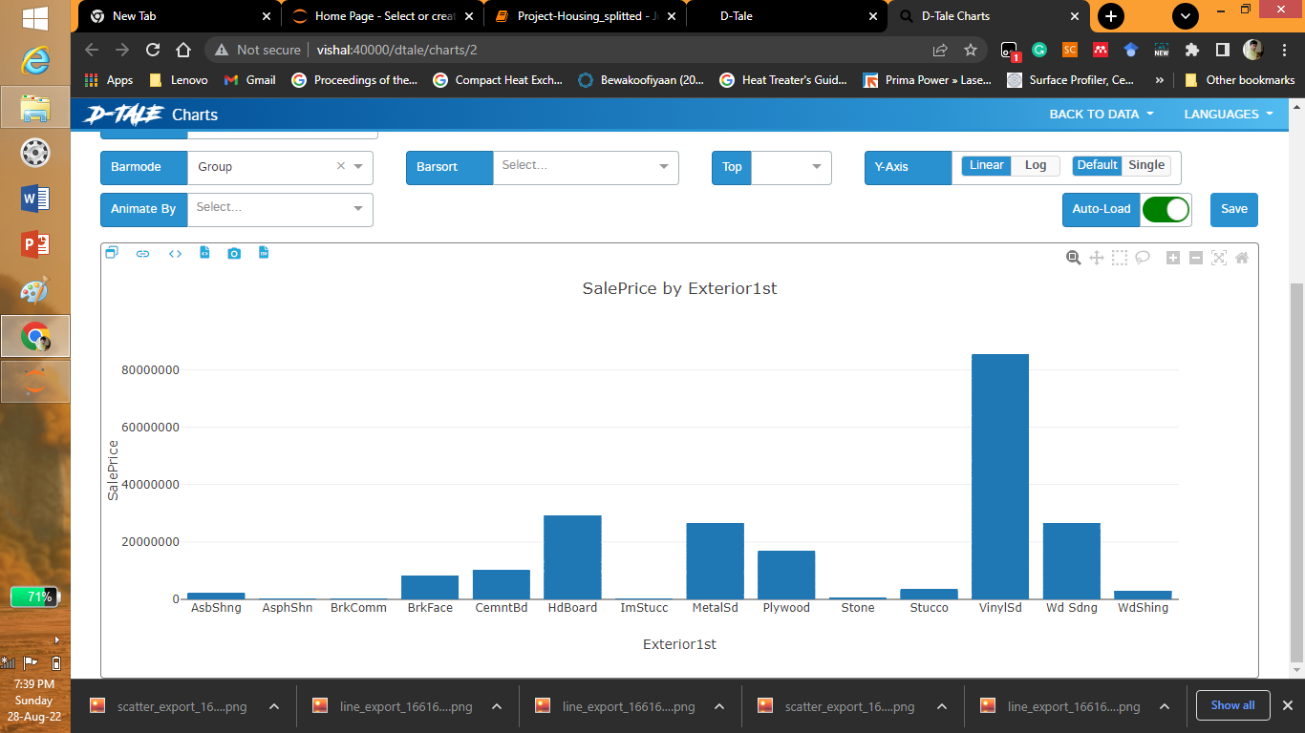

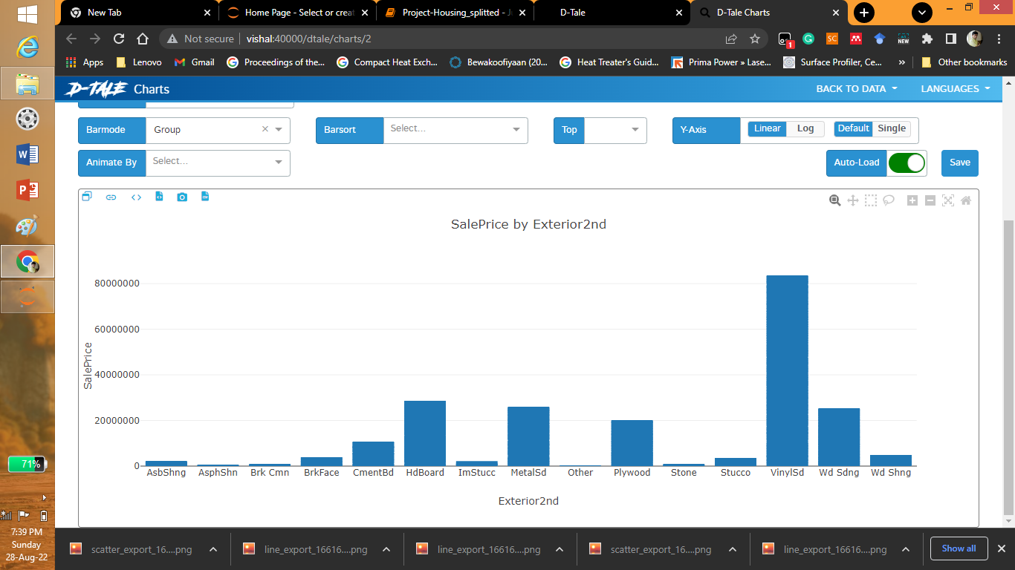

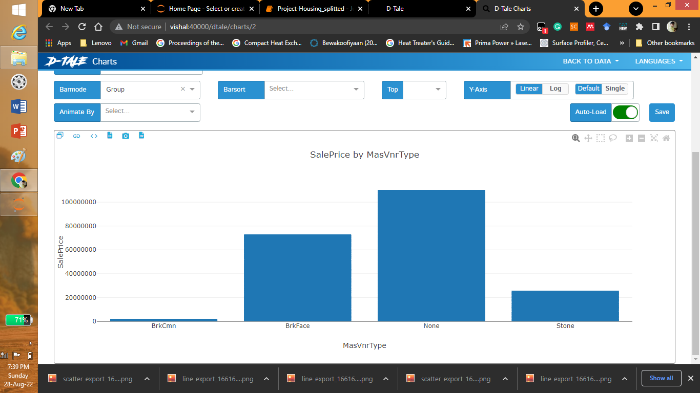

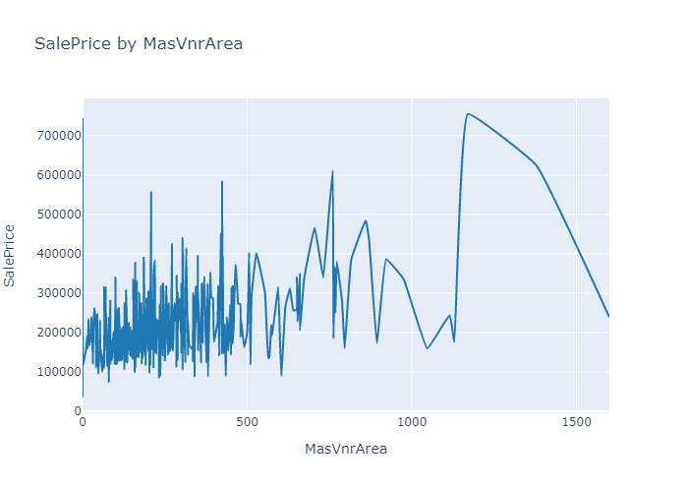

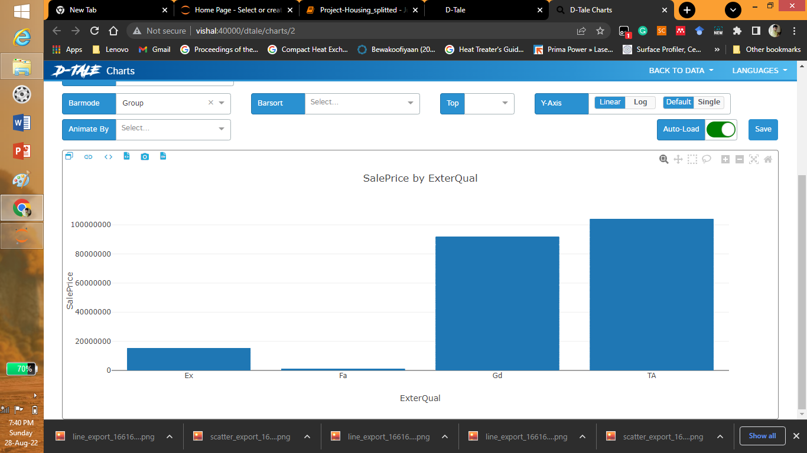

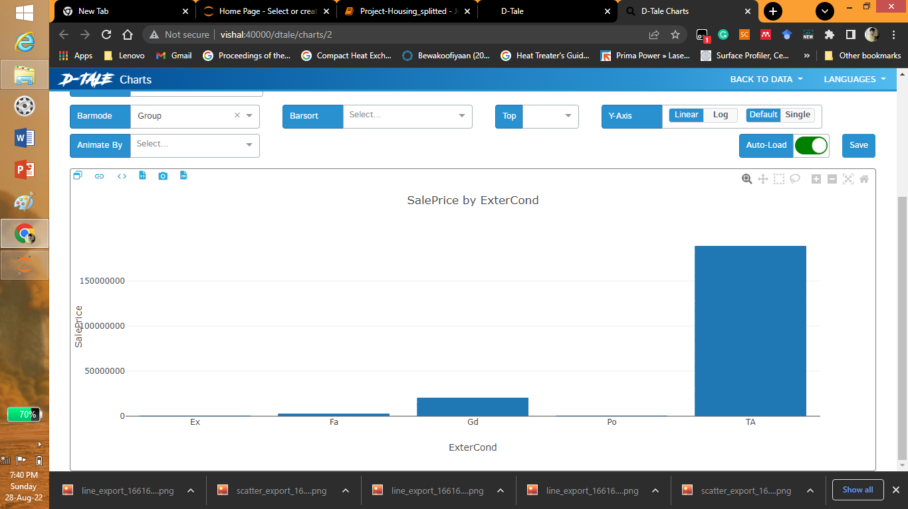

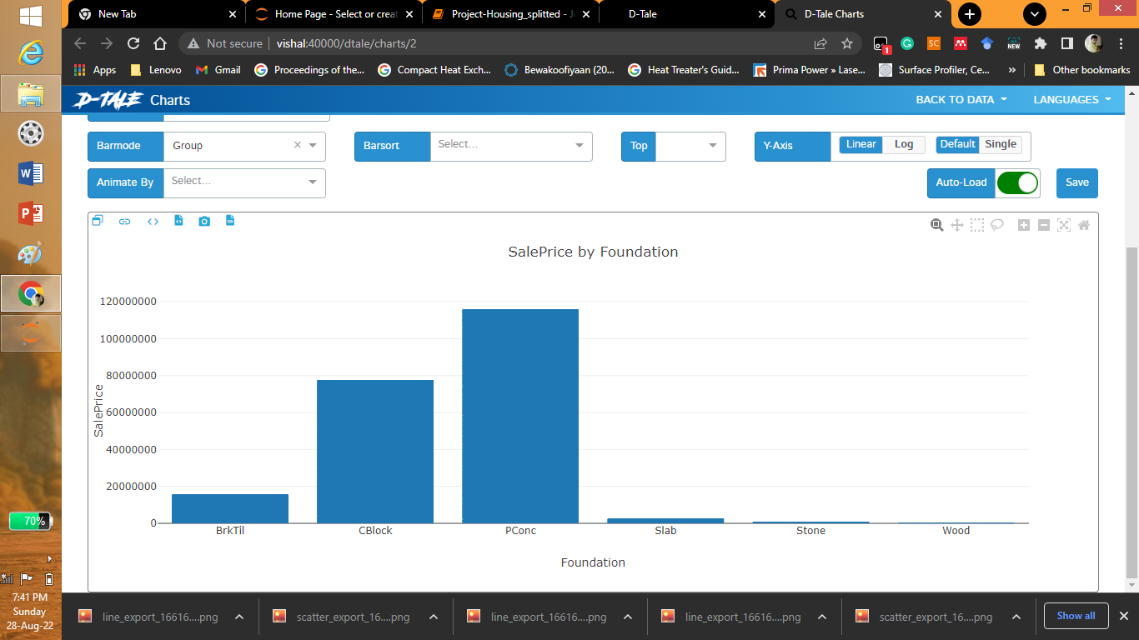

## C:\Users\Vishal Manoj\Downloads\26.png

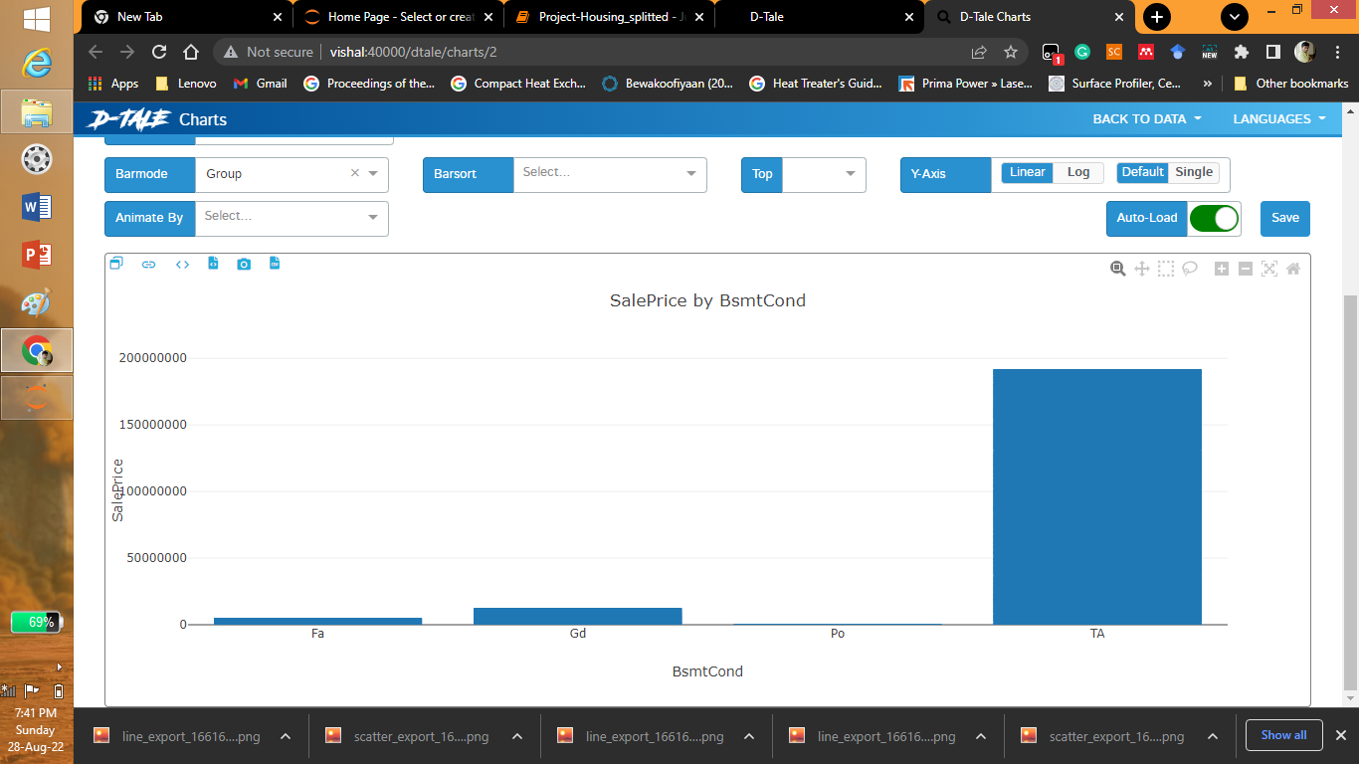

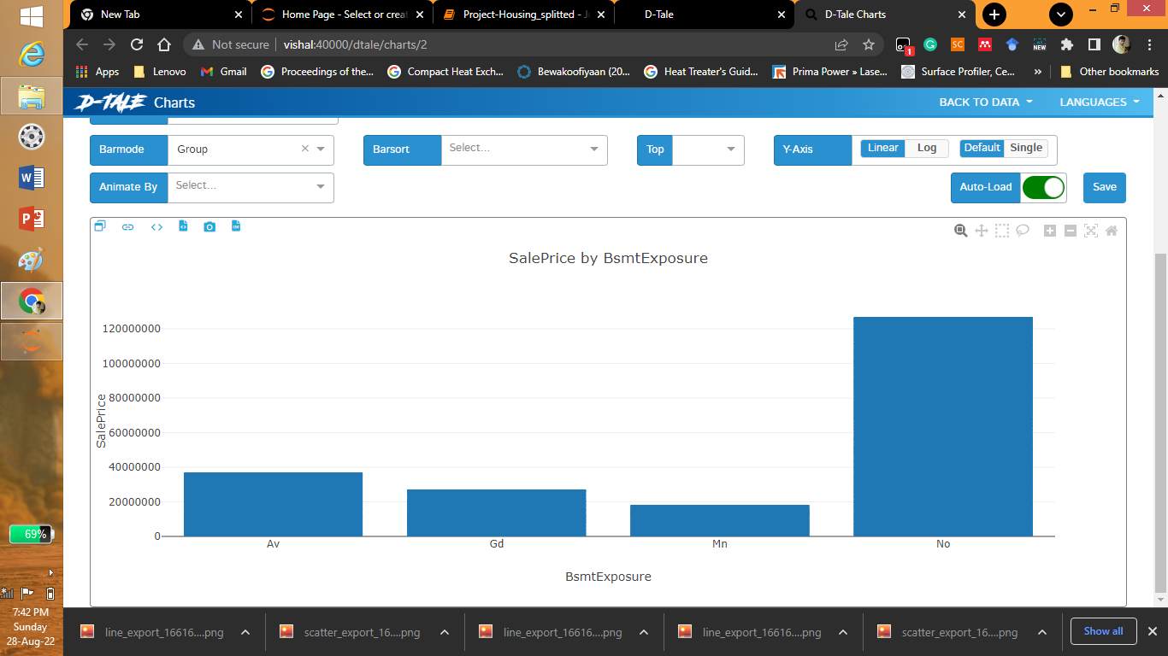

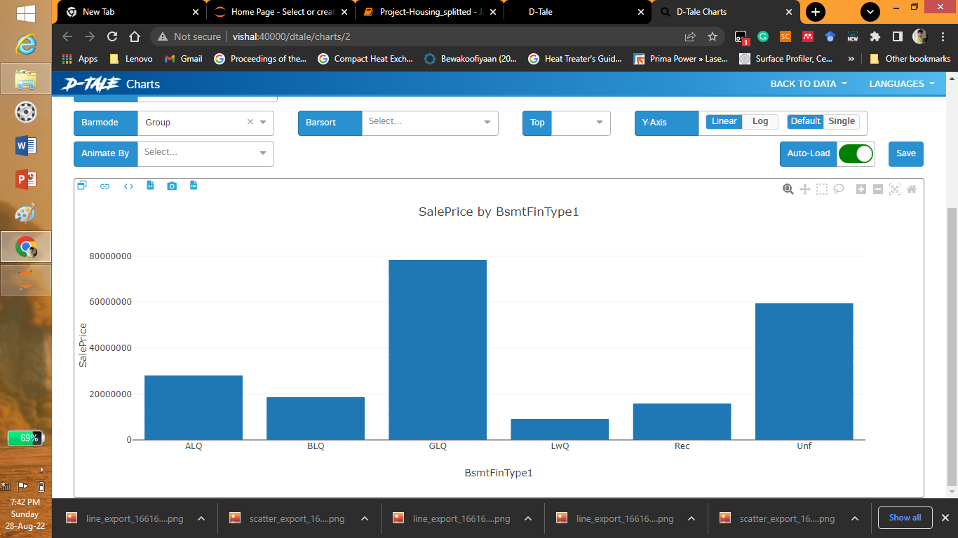

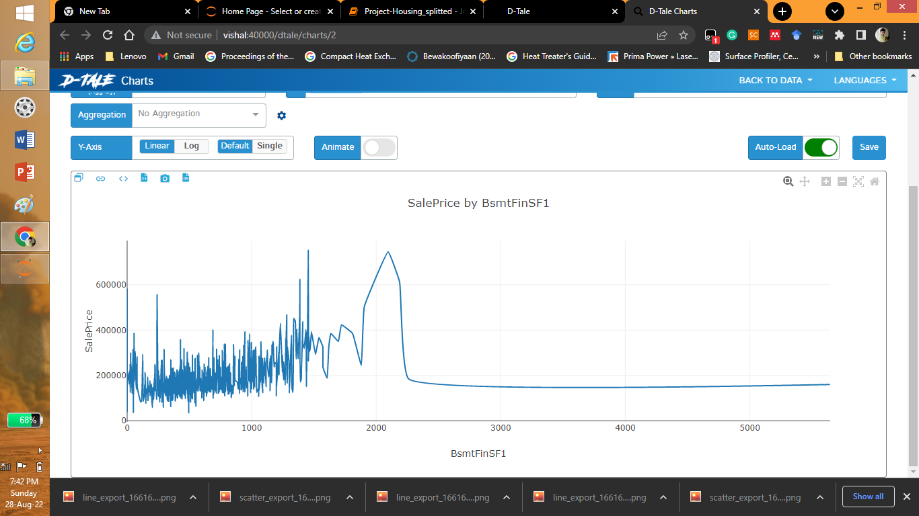

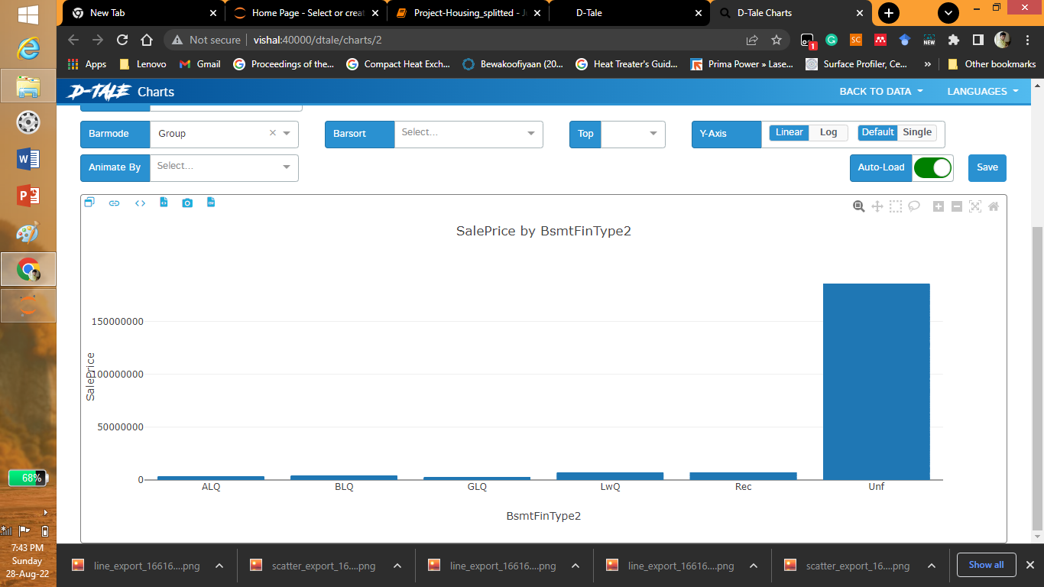

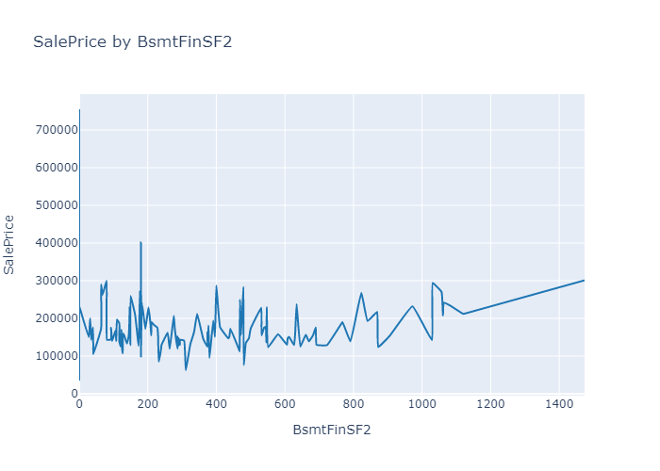

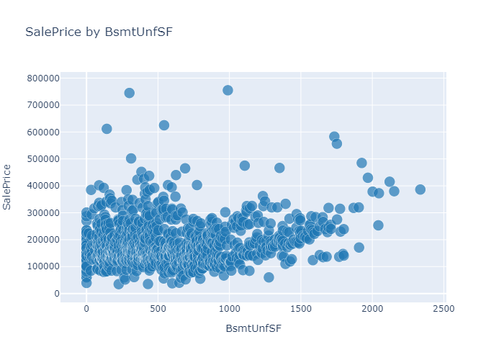

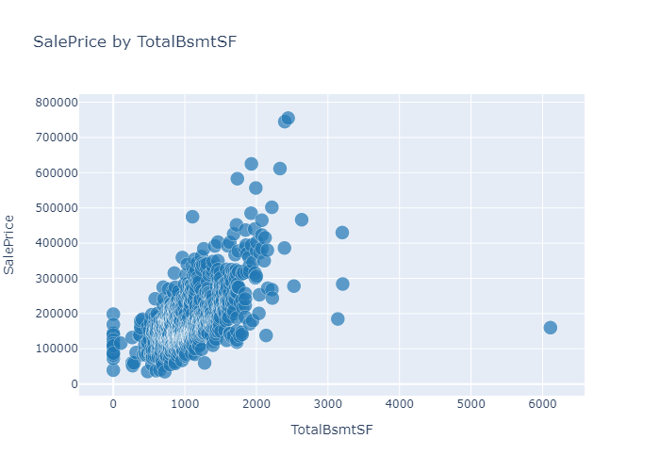

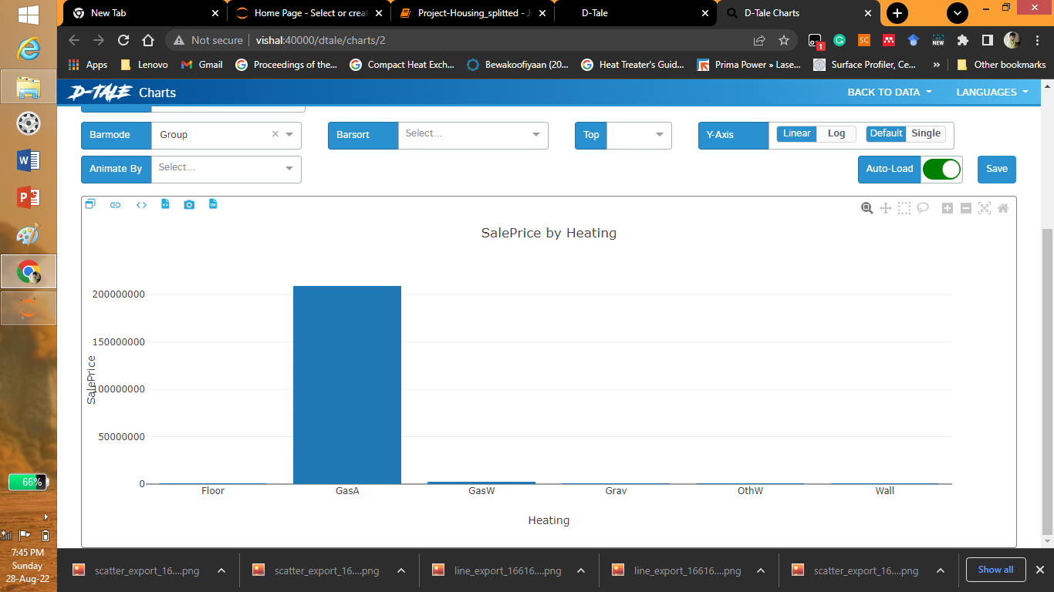

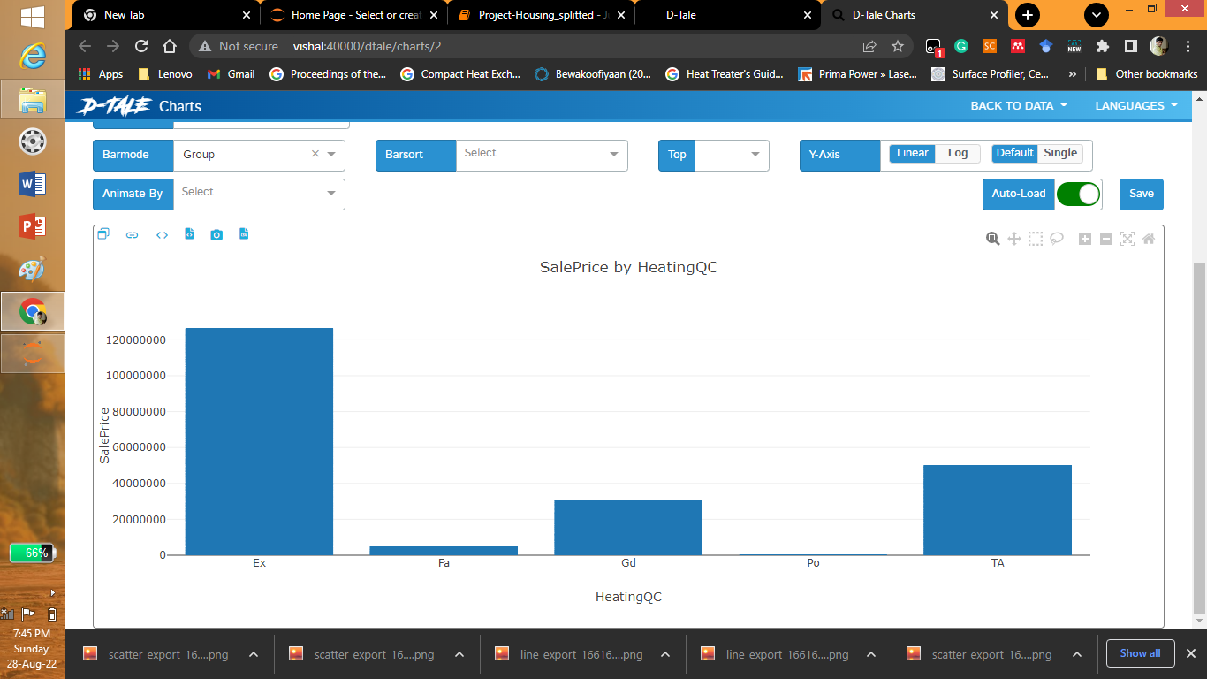

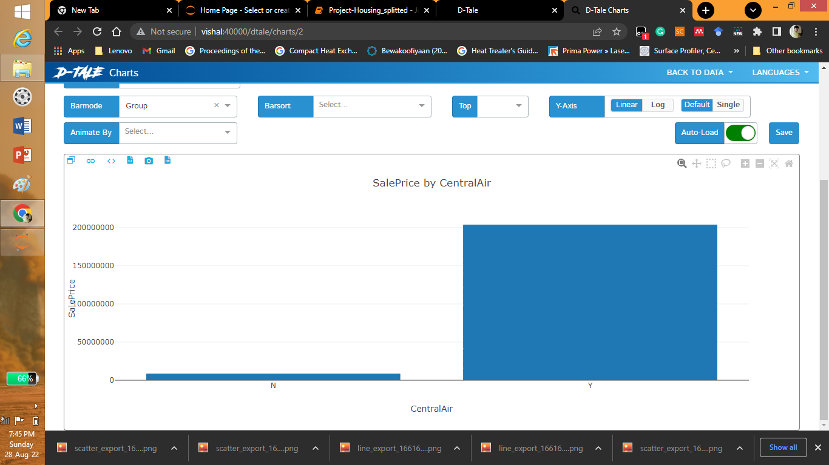

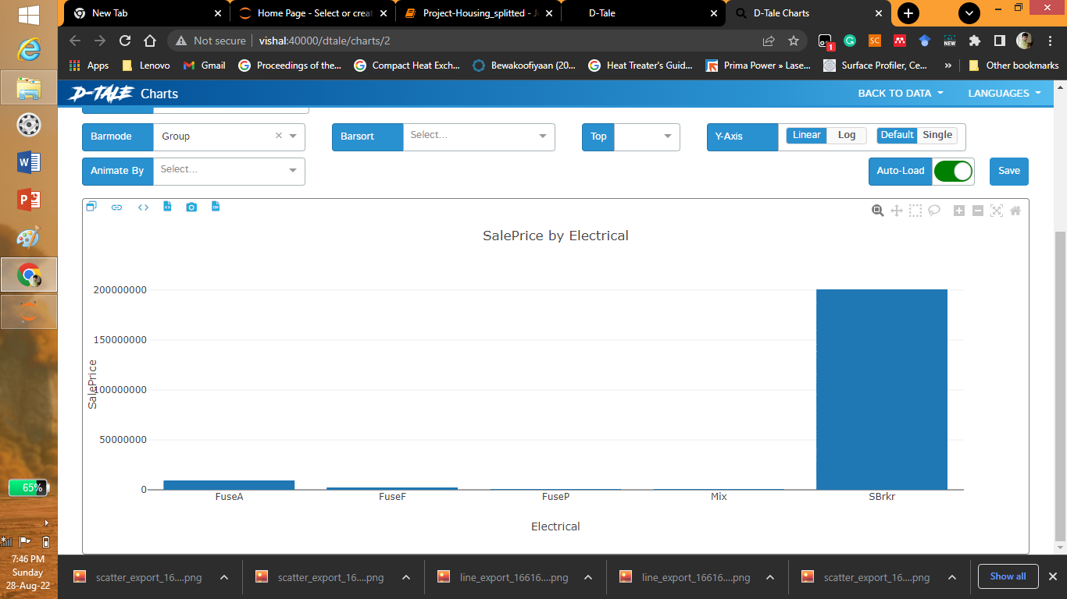

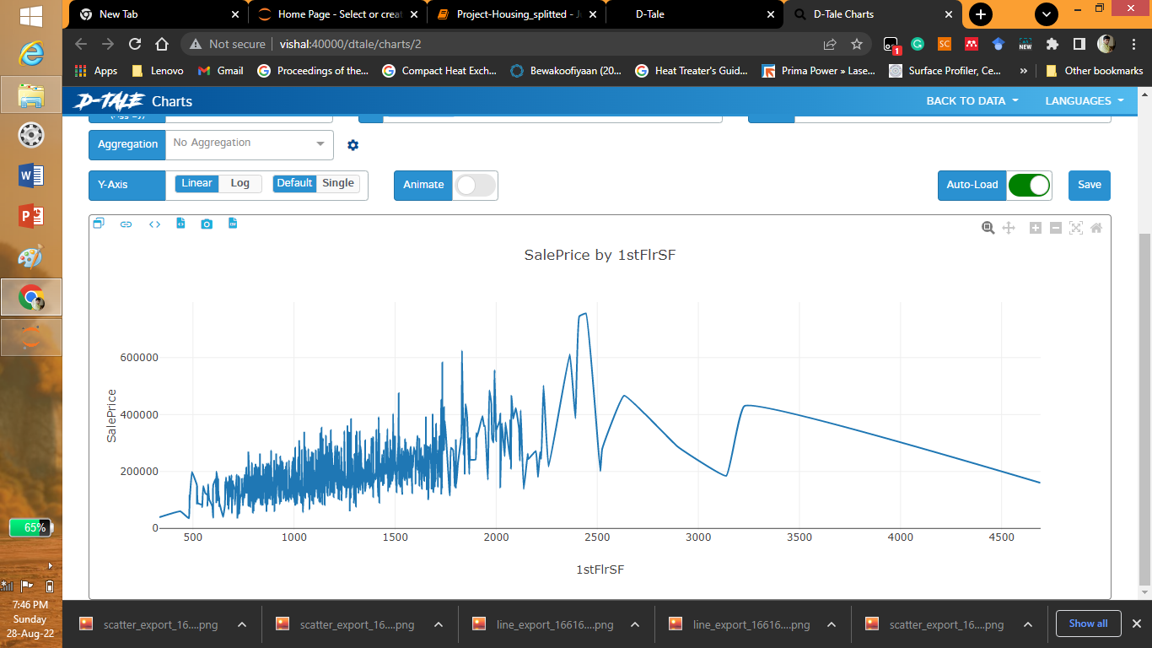

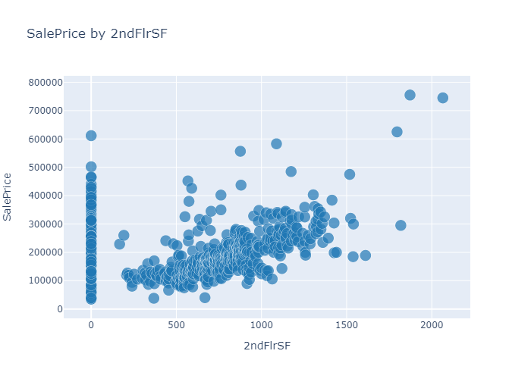

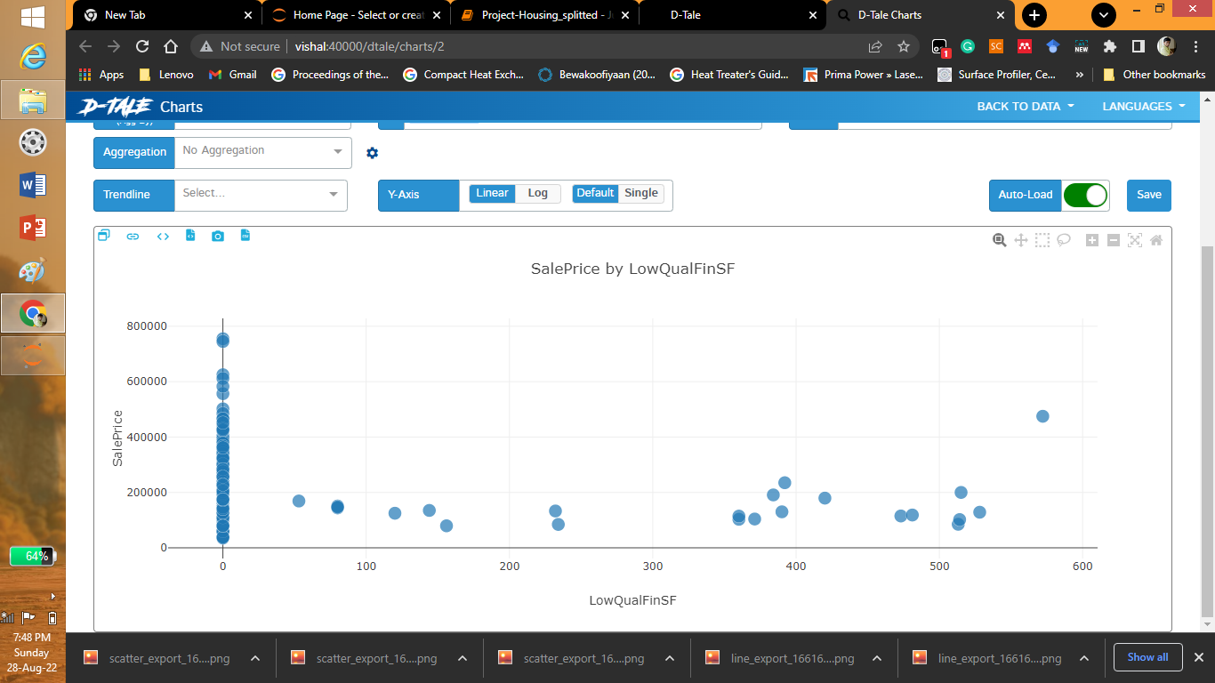

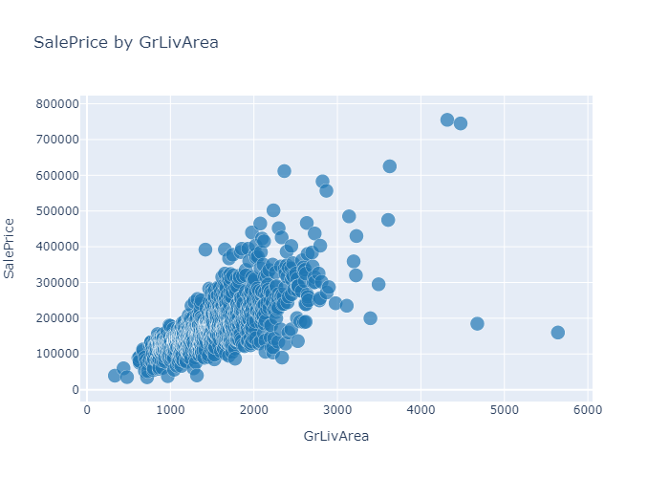

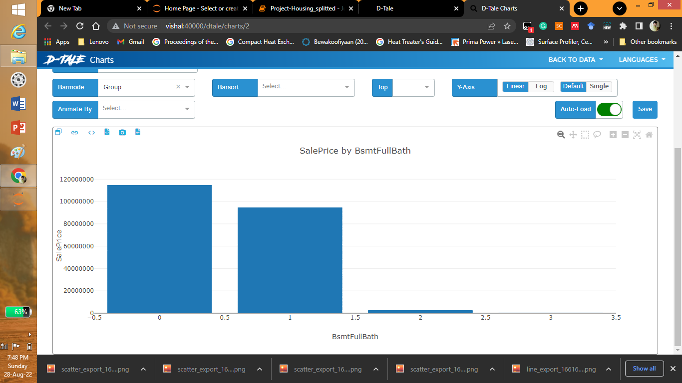

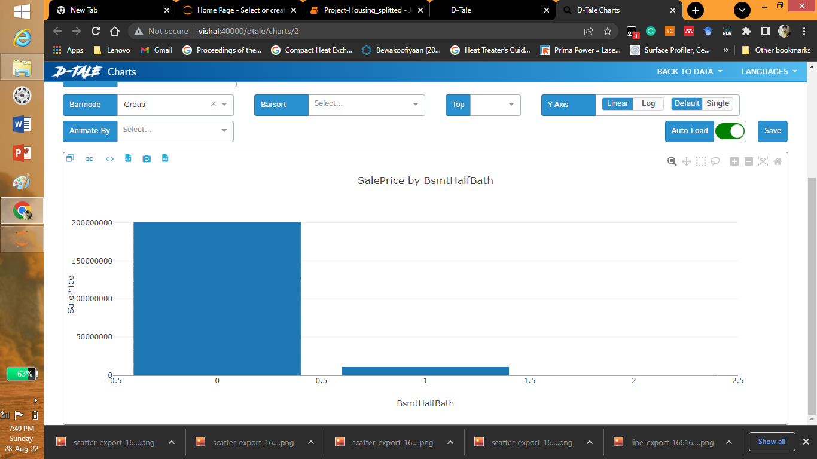

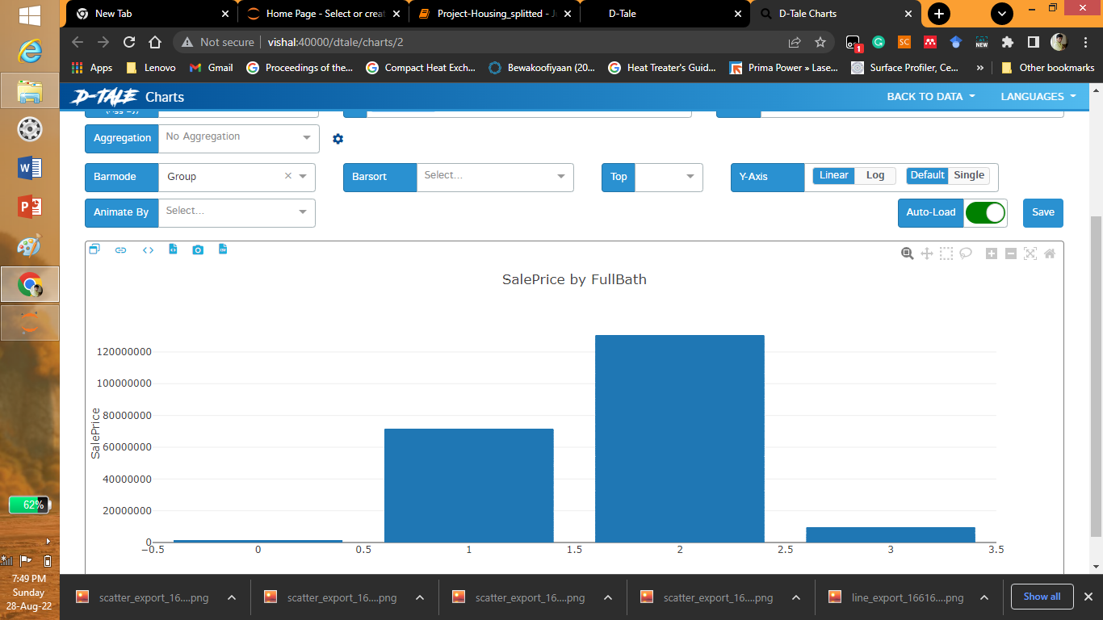

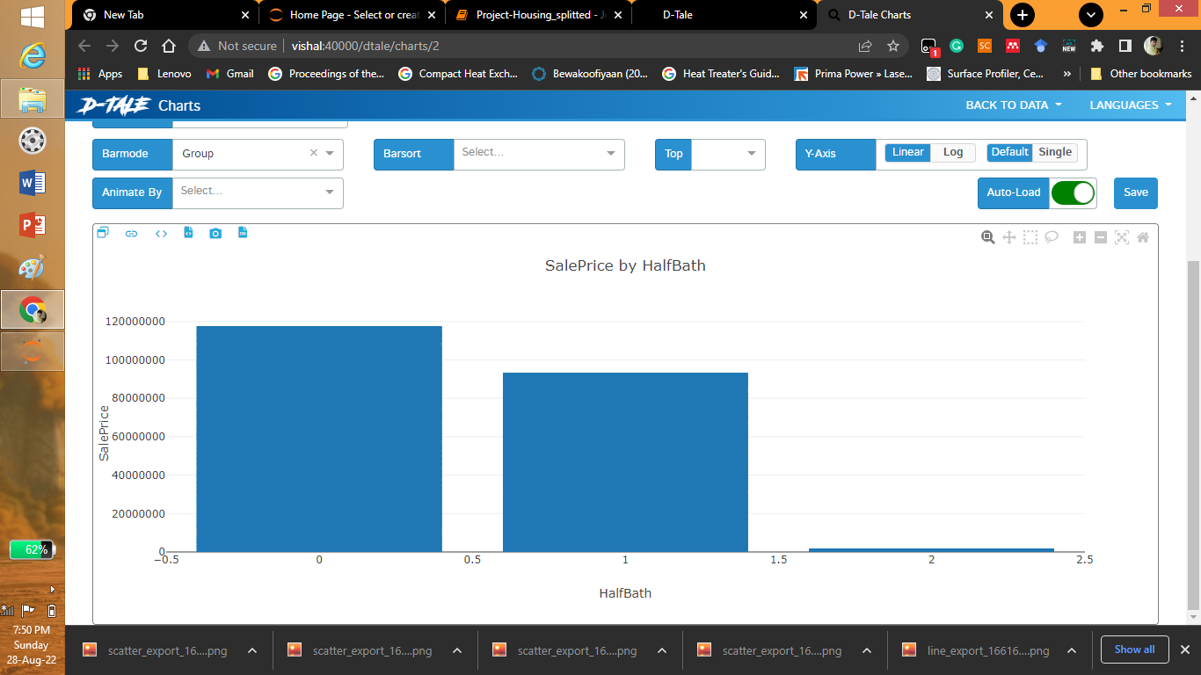

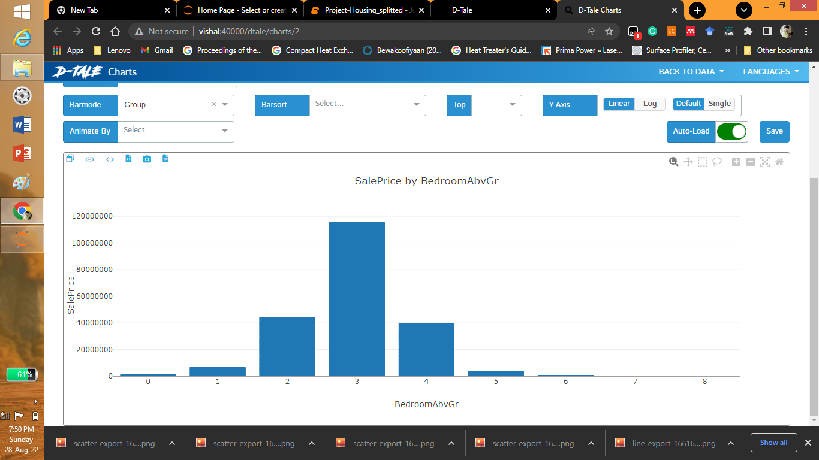

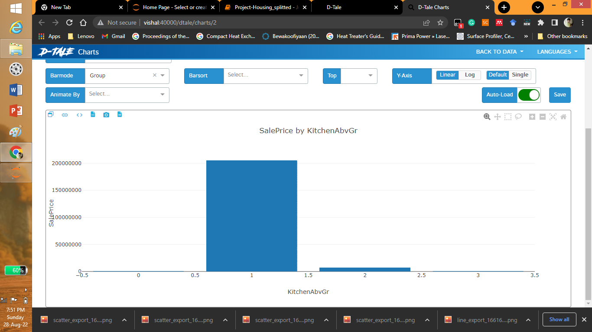

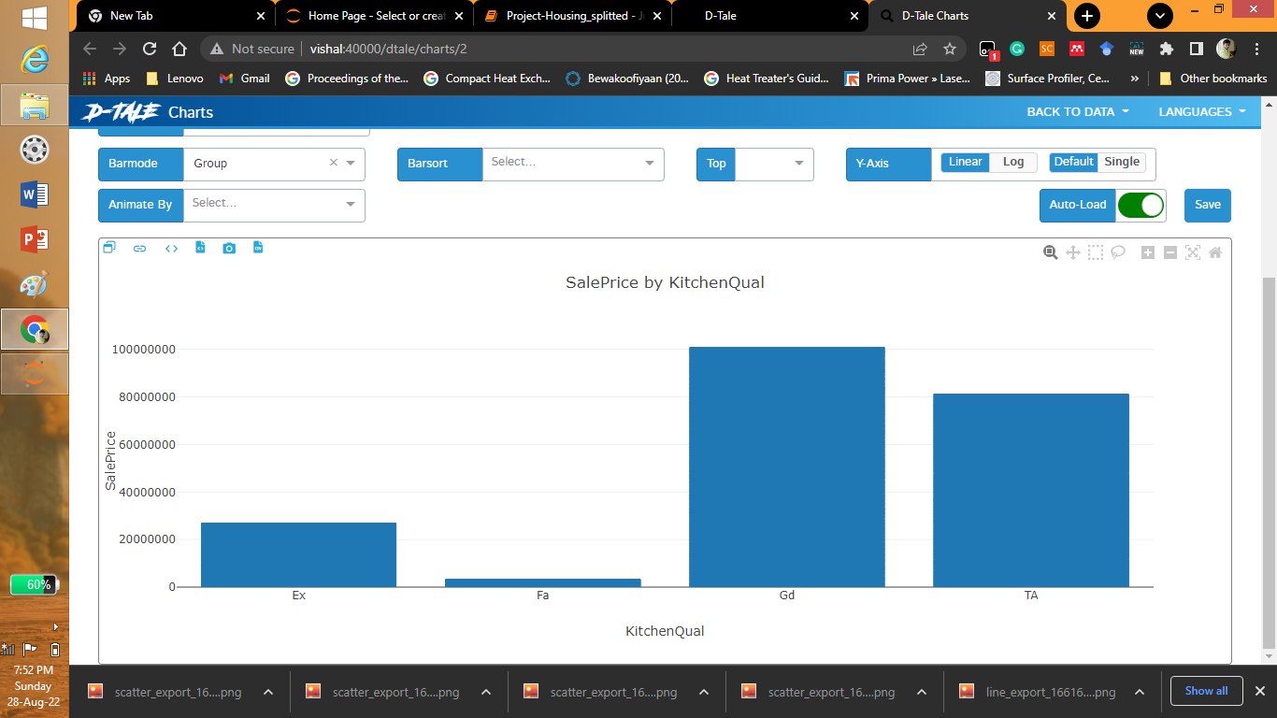

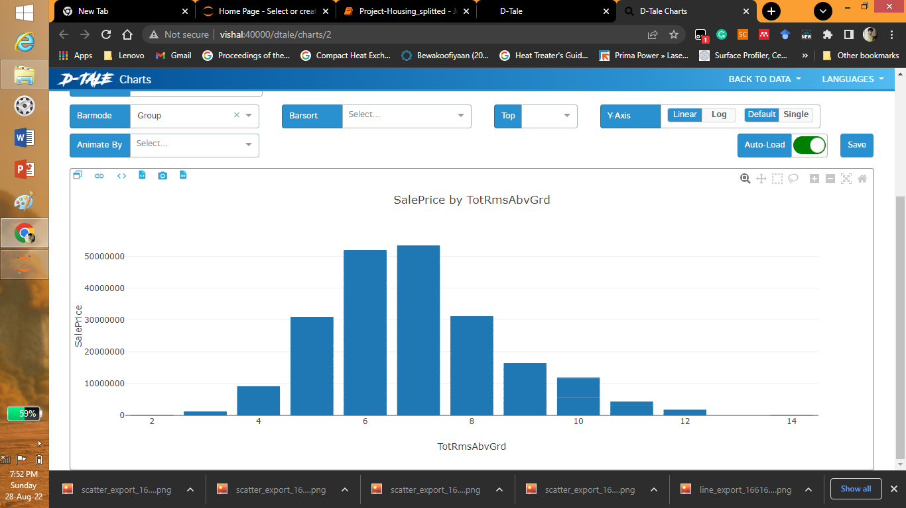

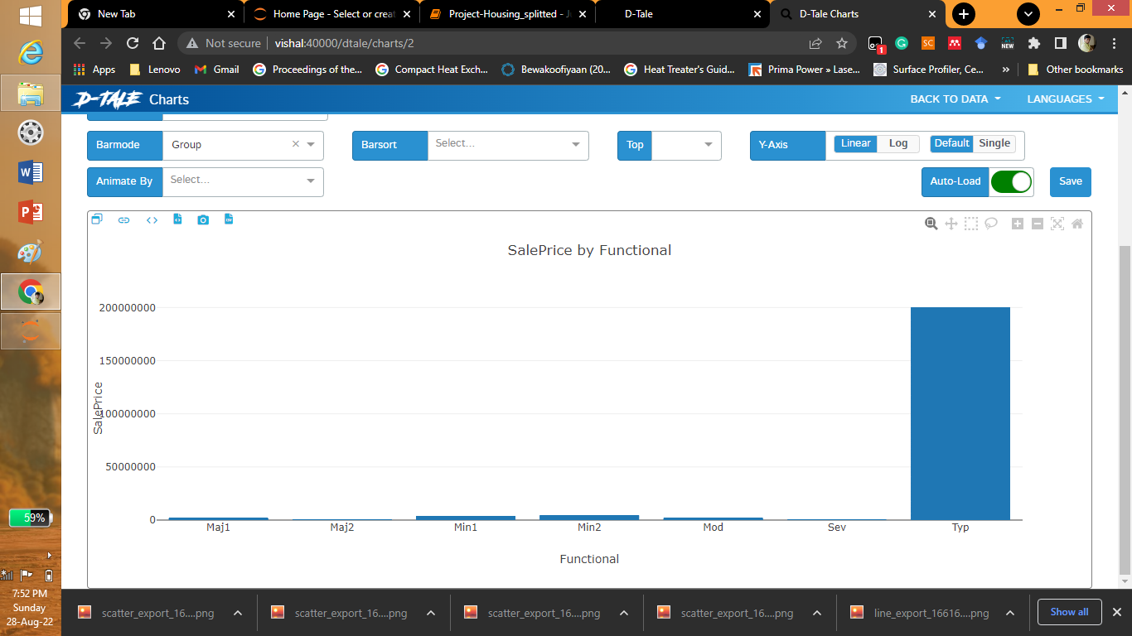

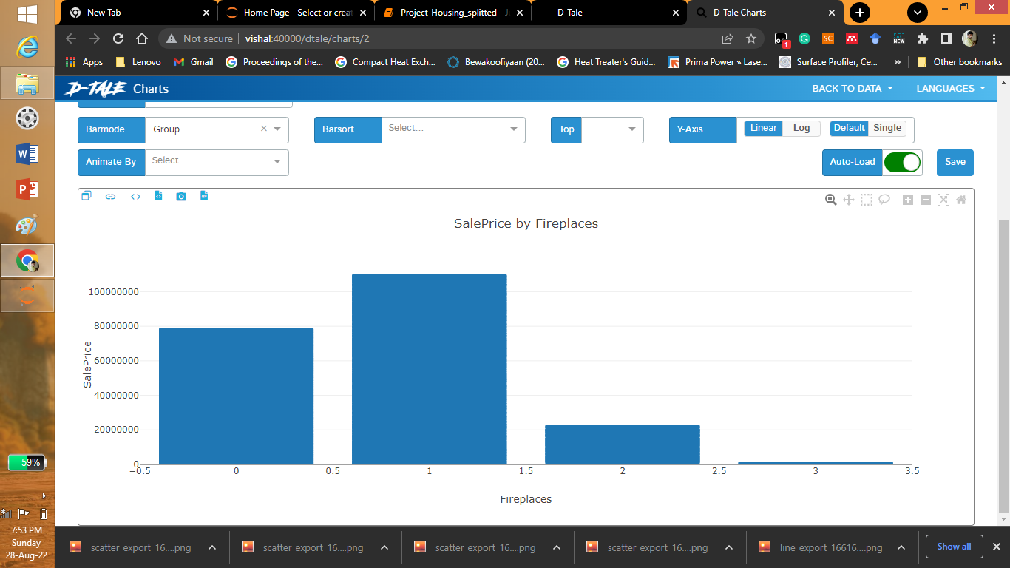

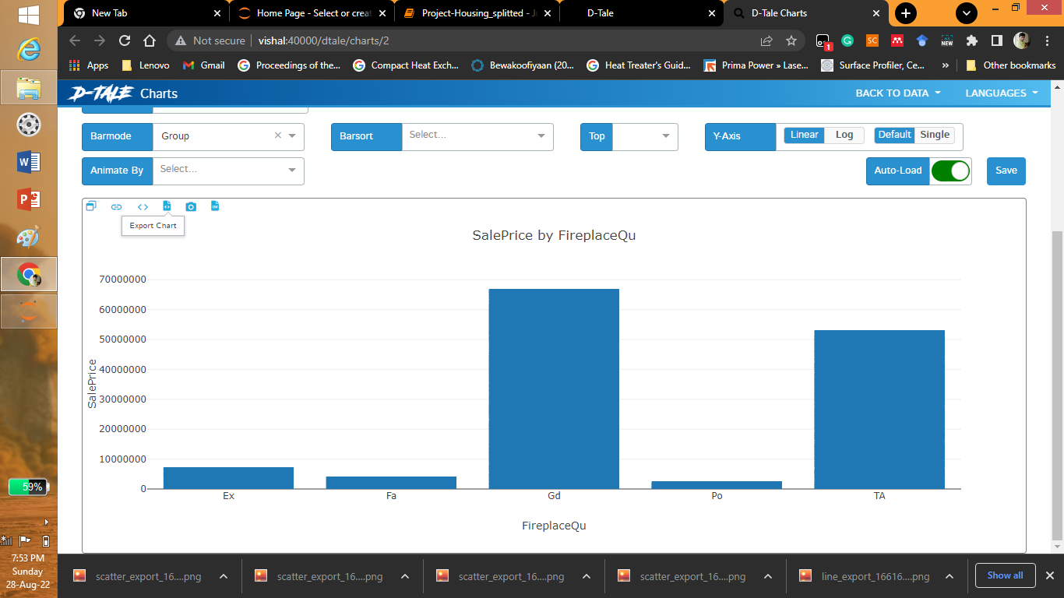

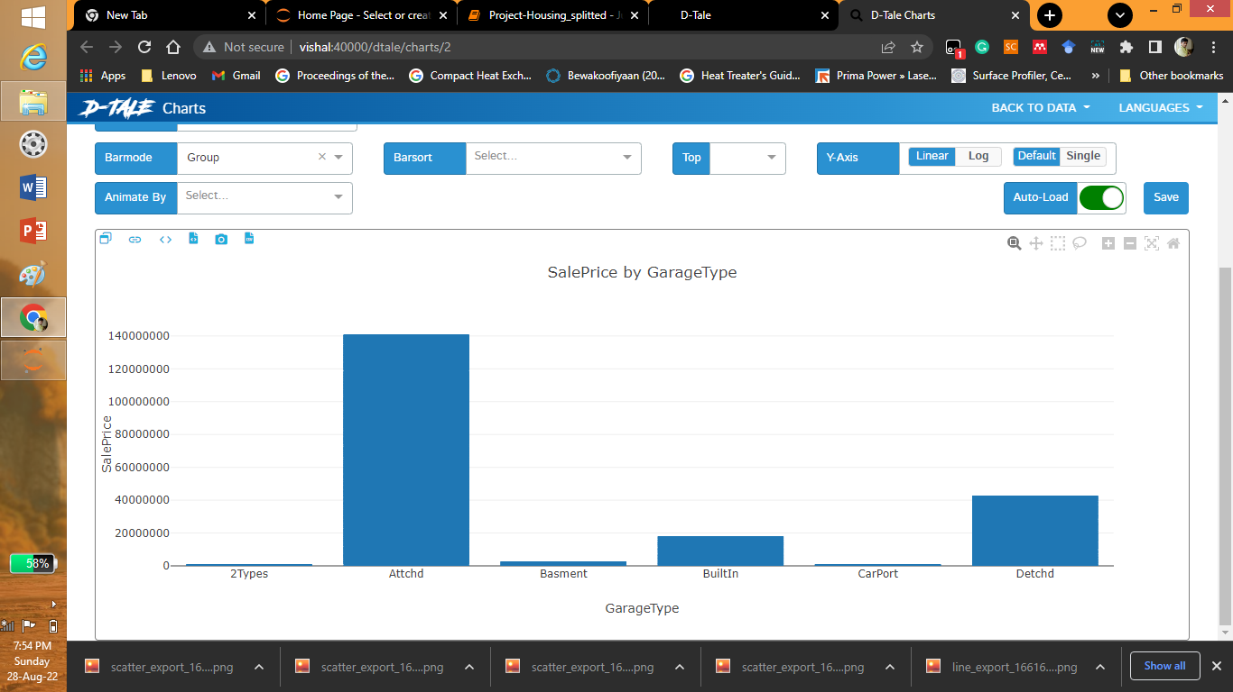

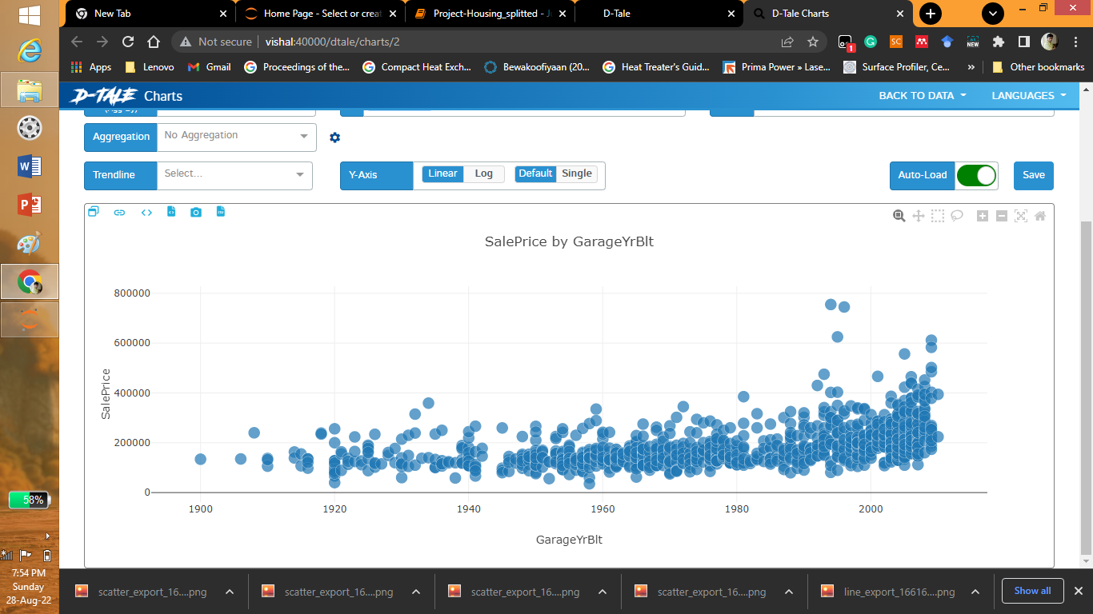

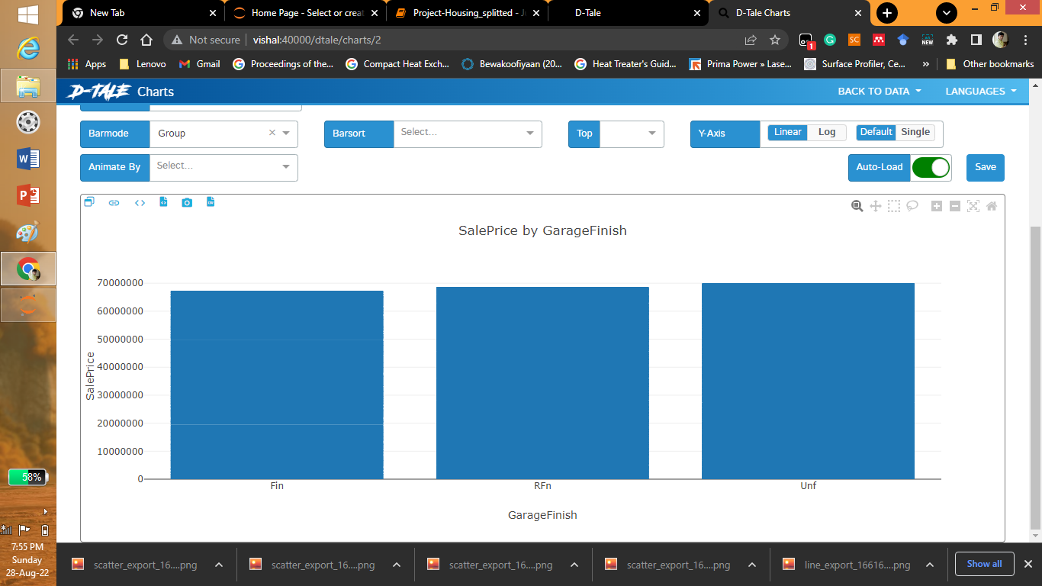

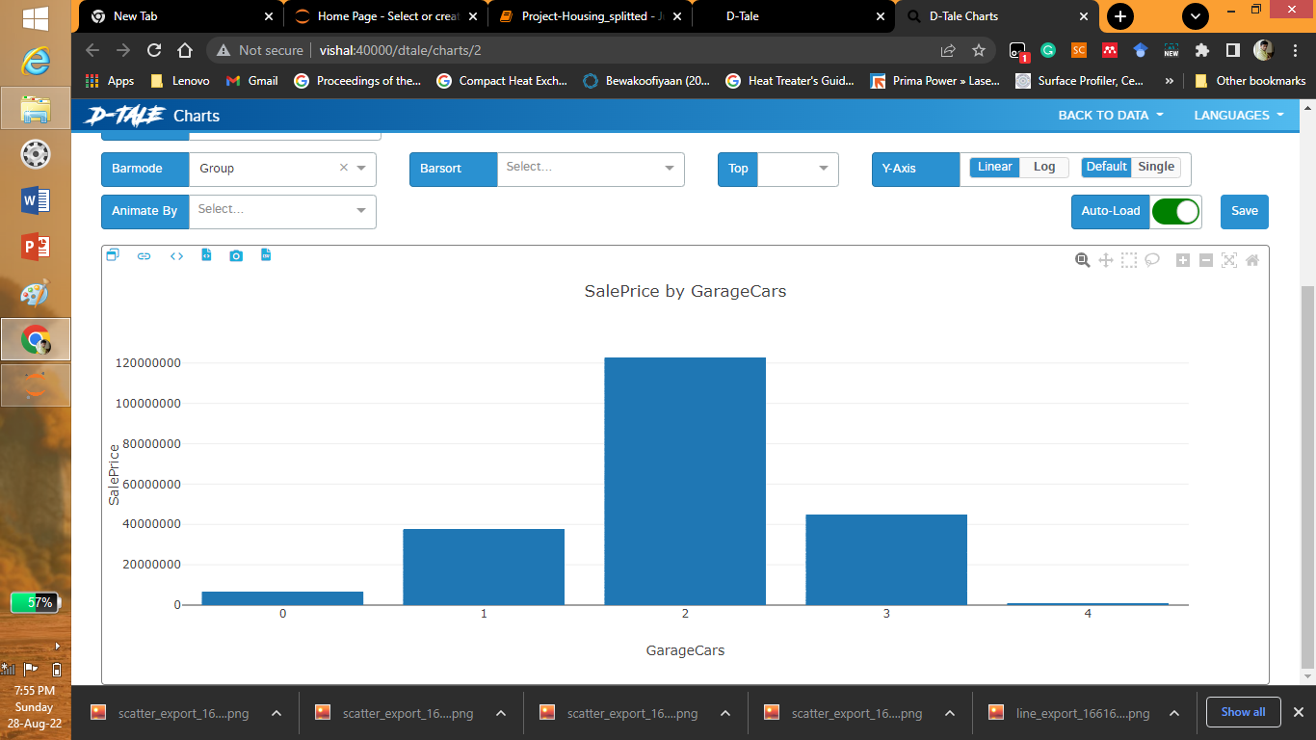

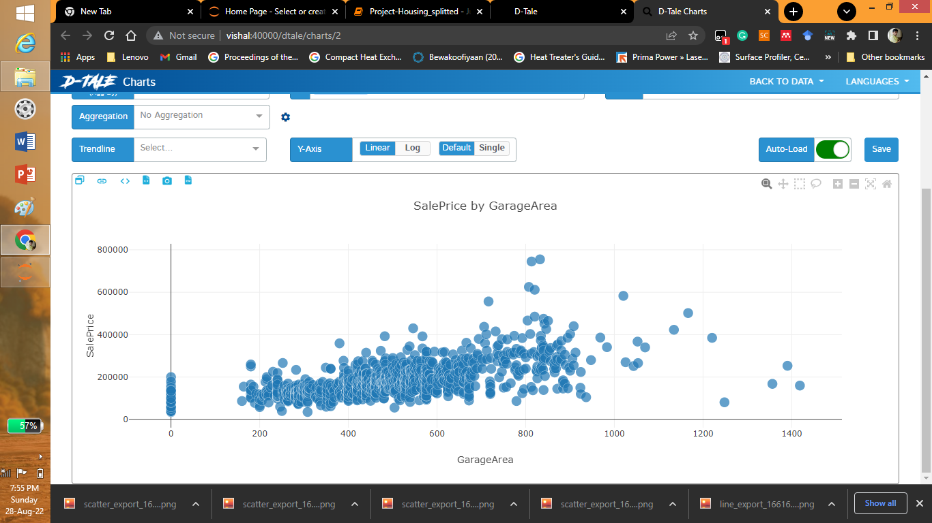

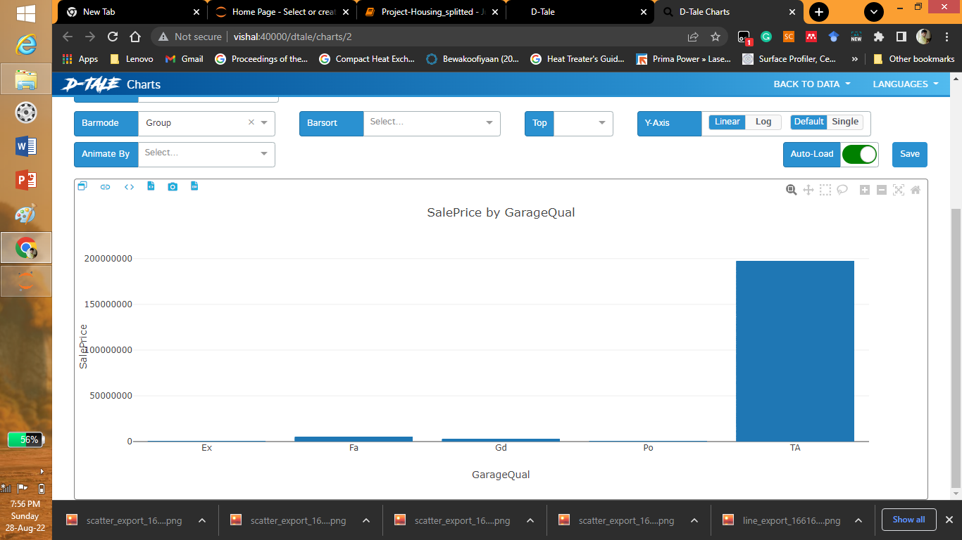

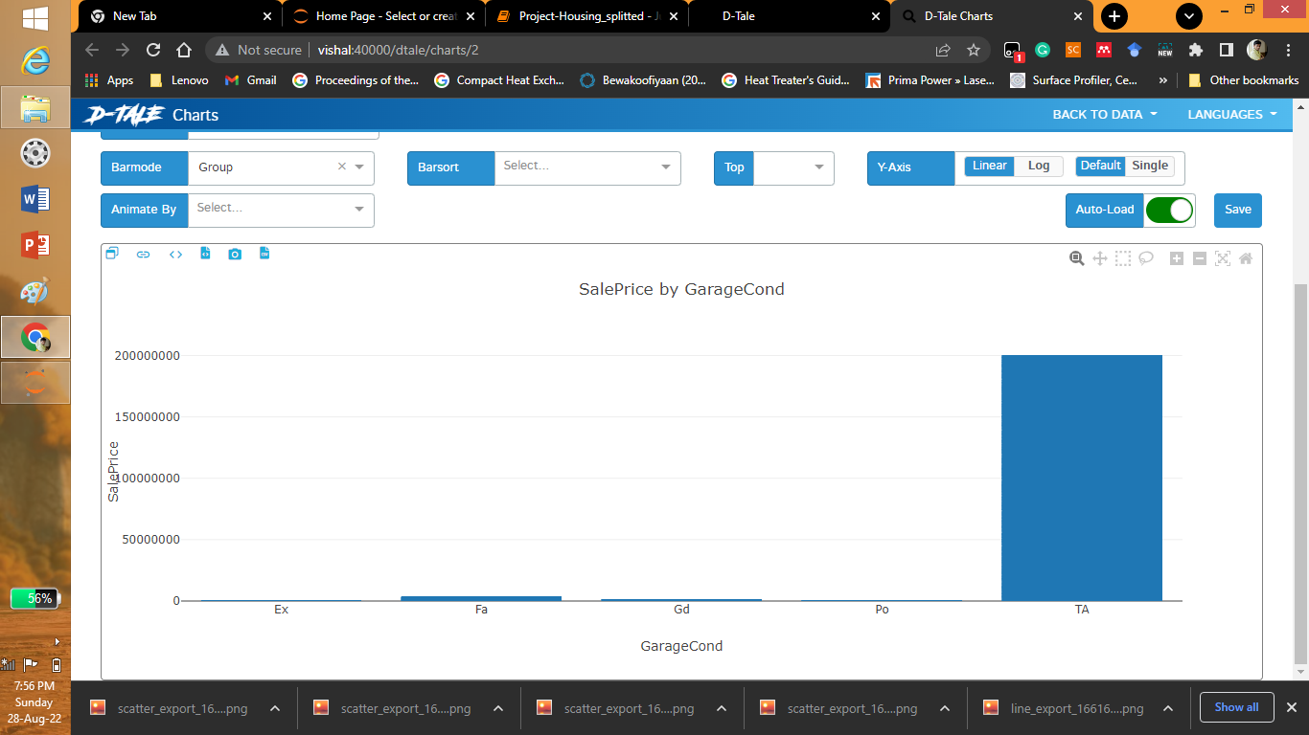

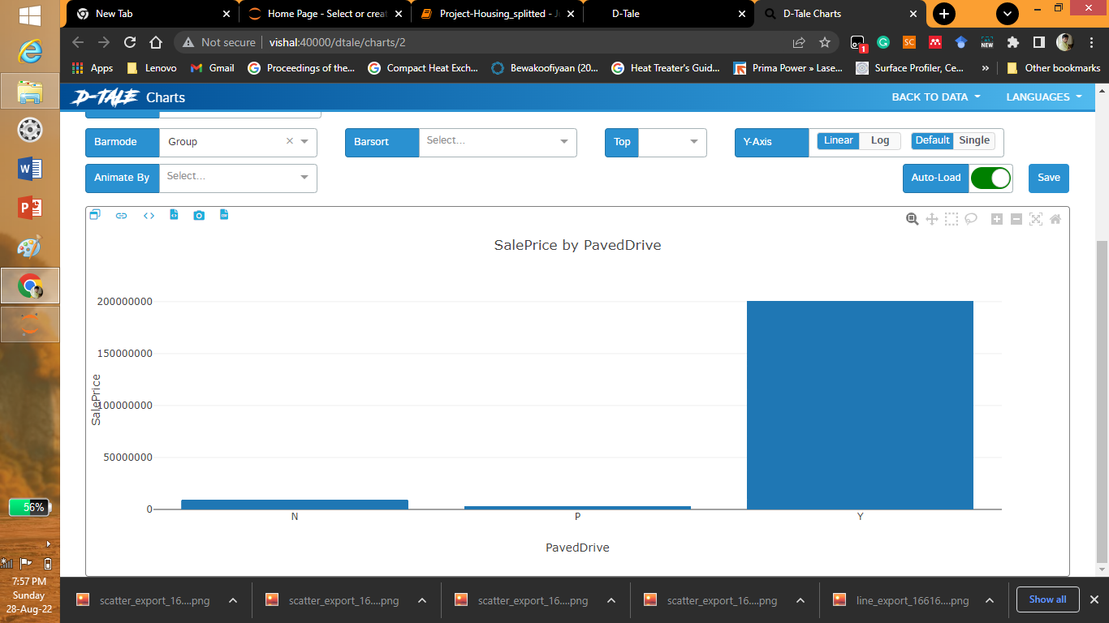

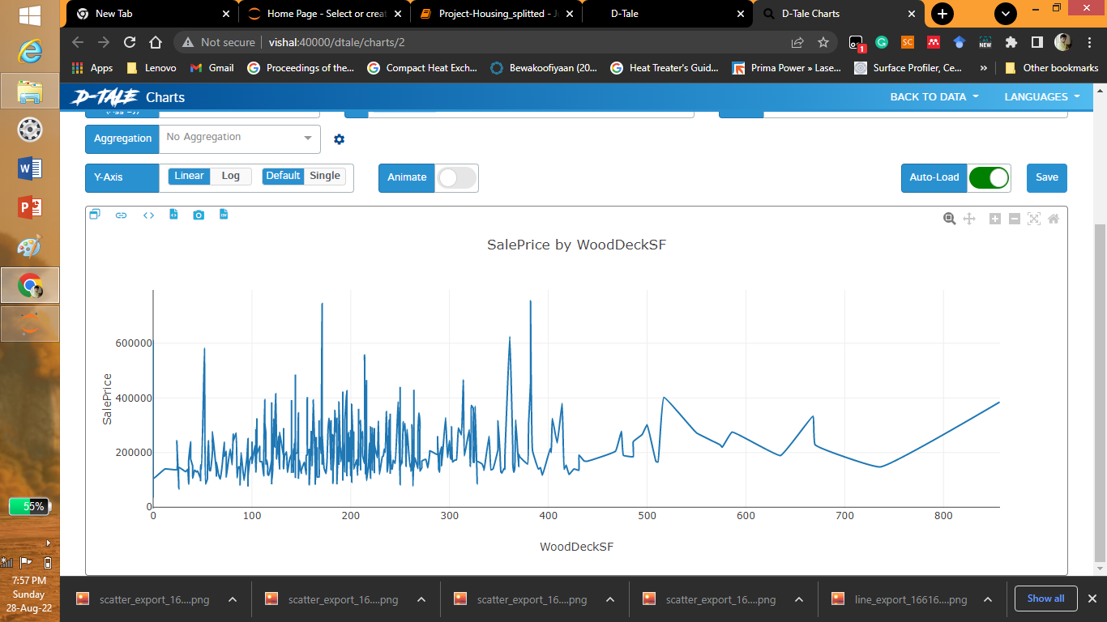

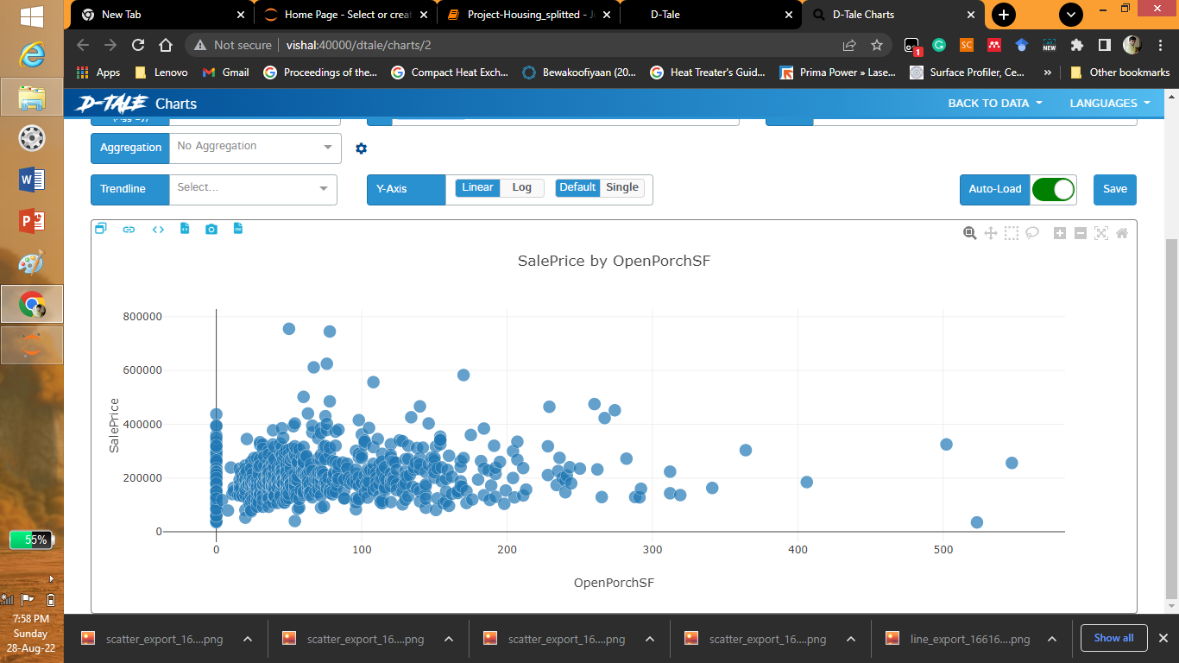

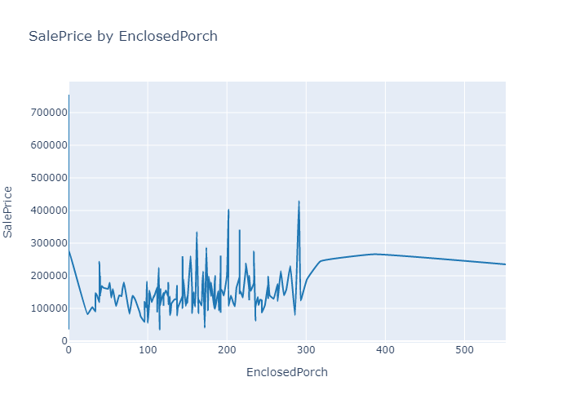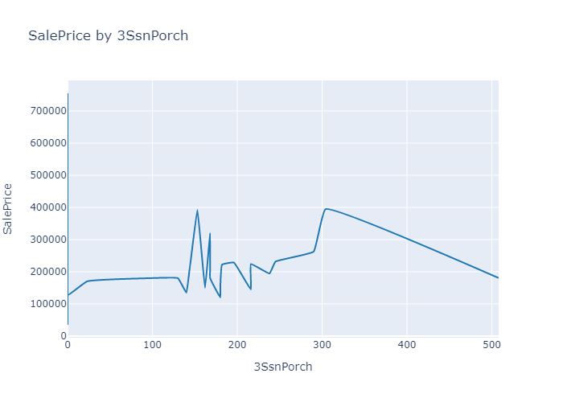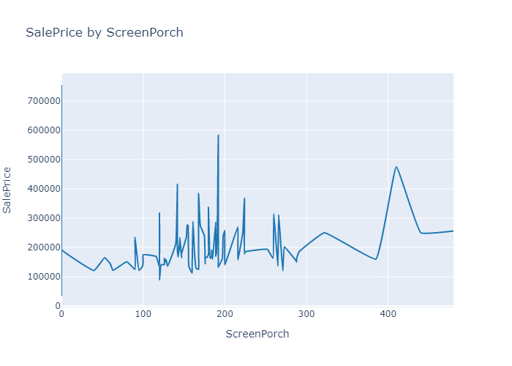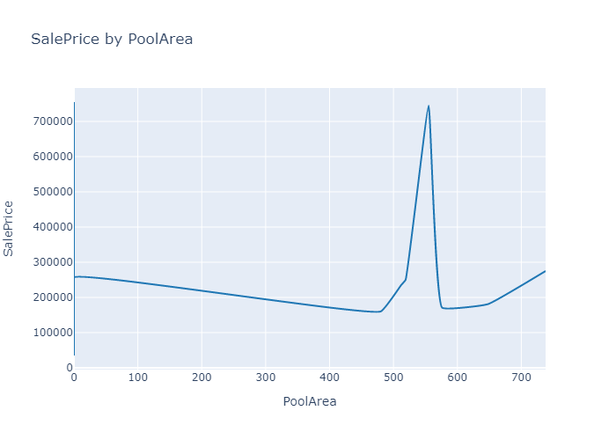

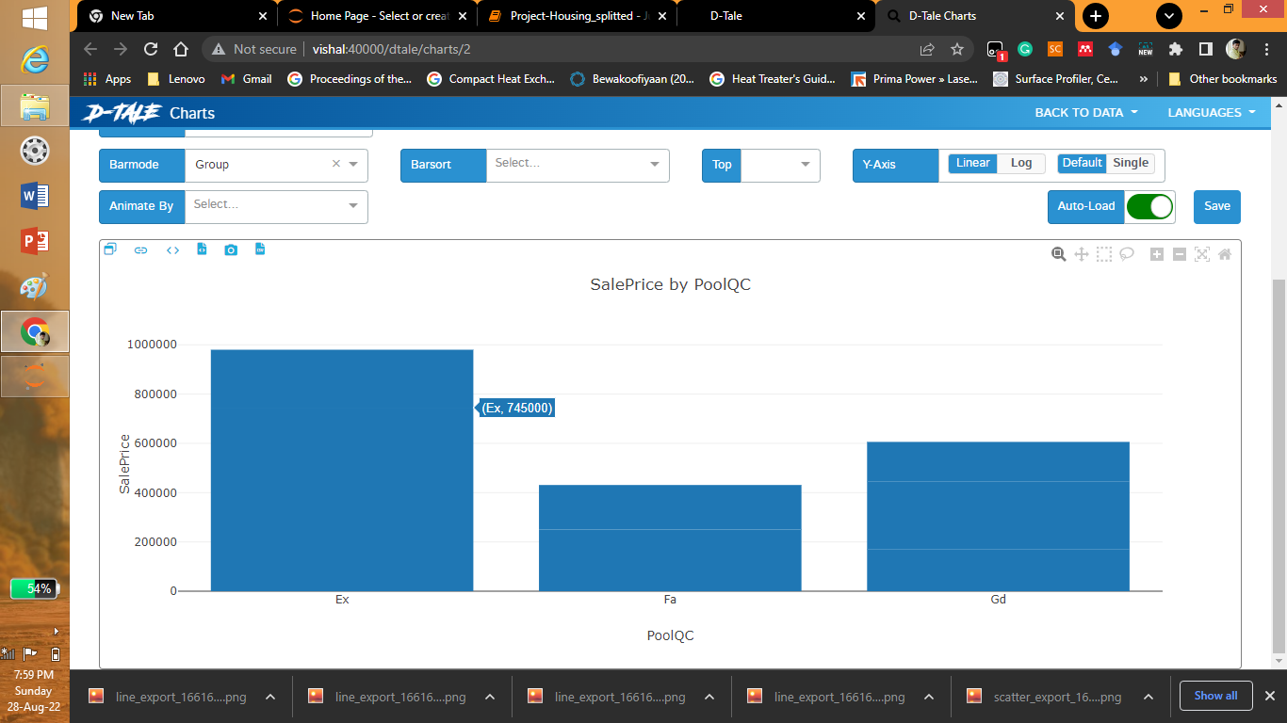

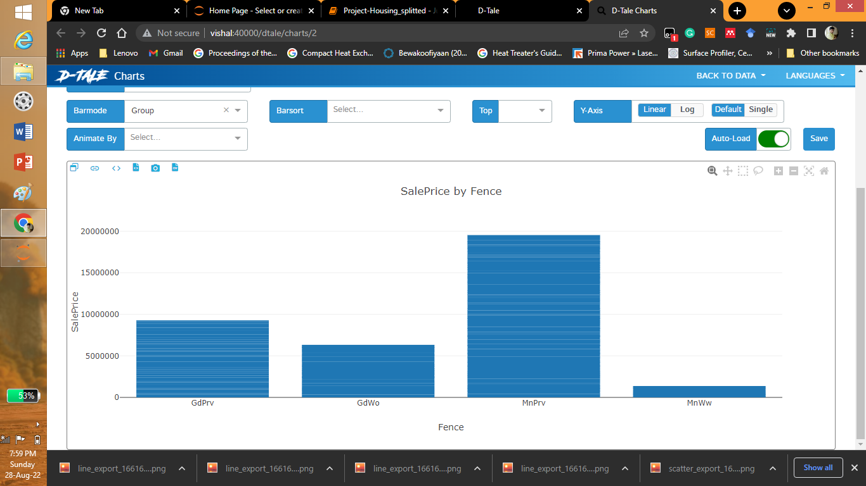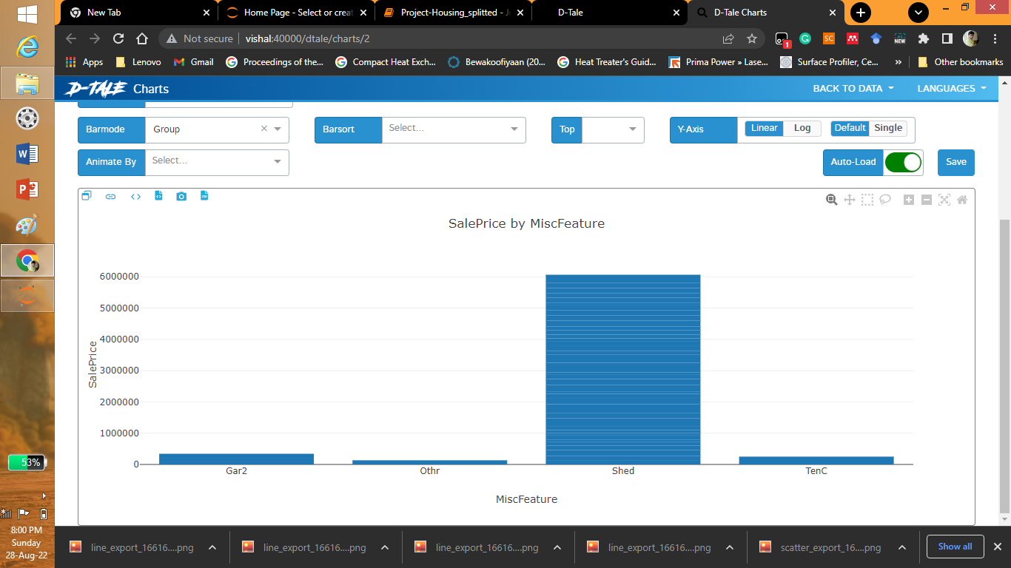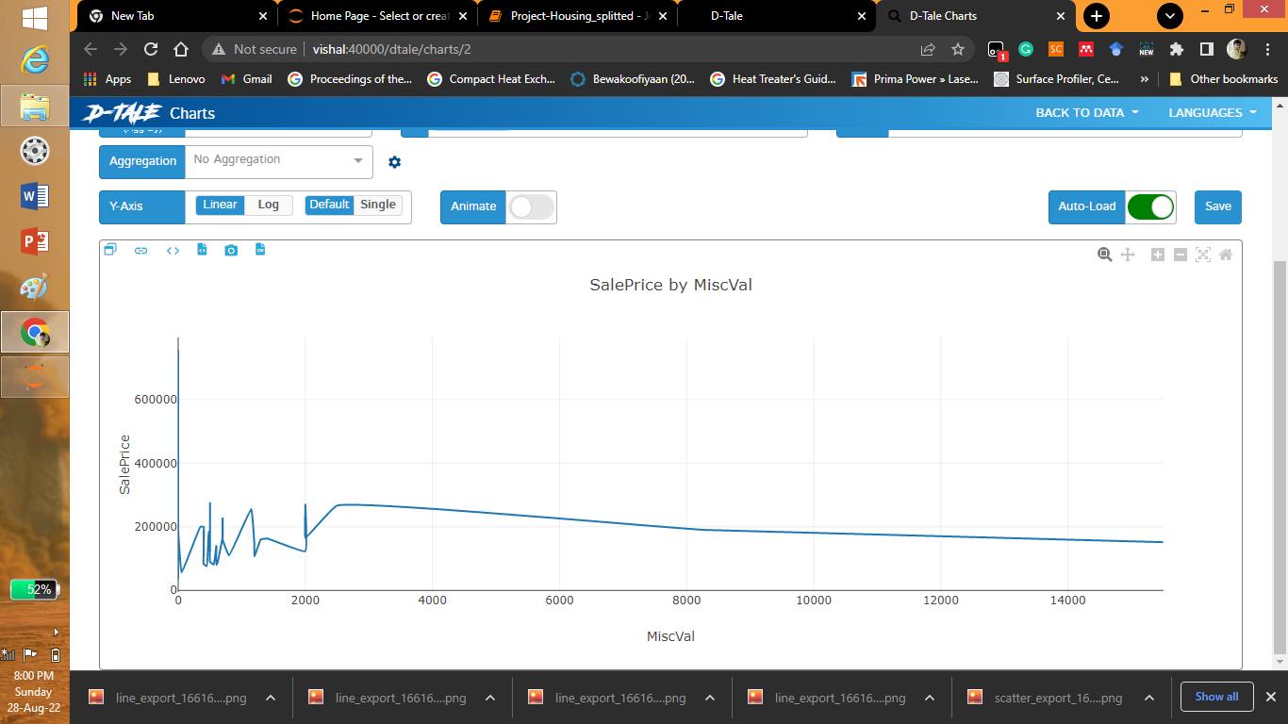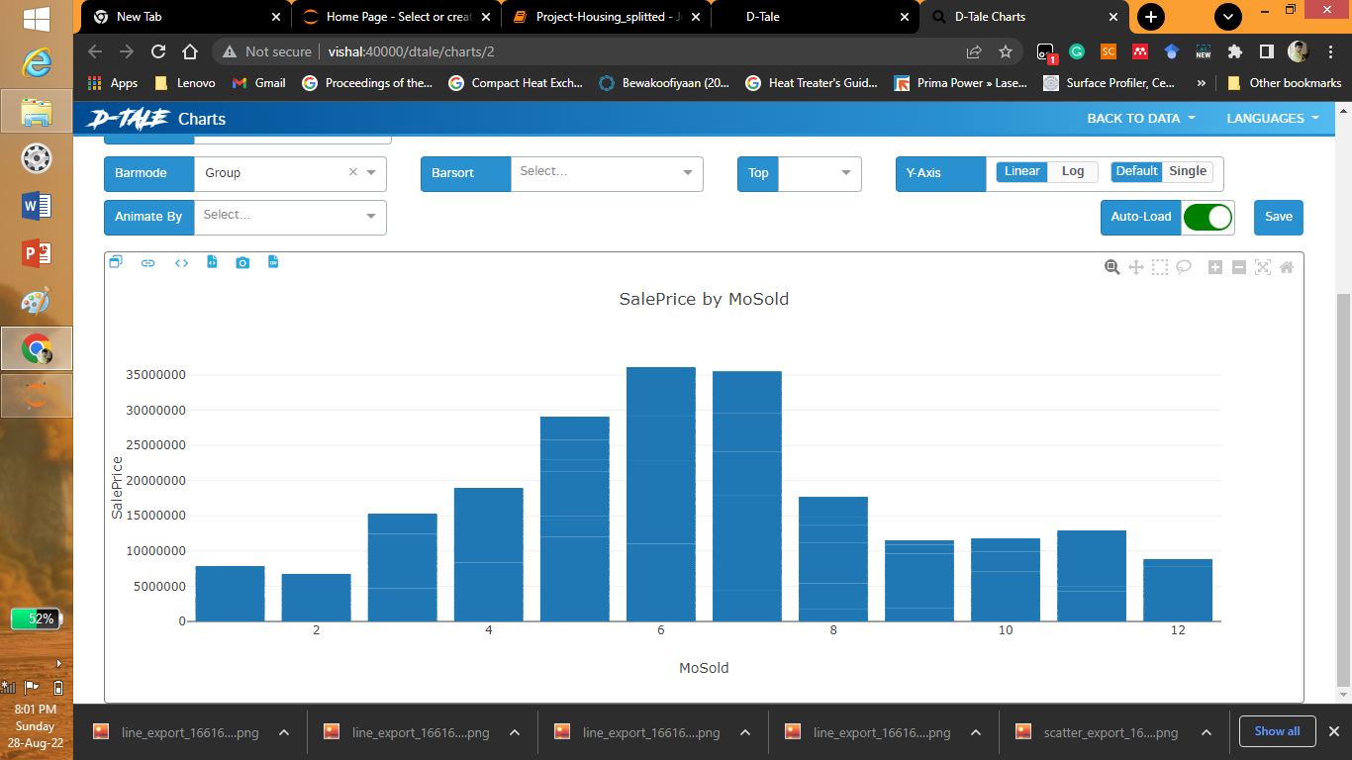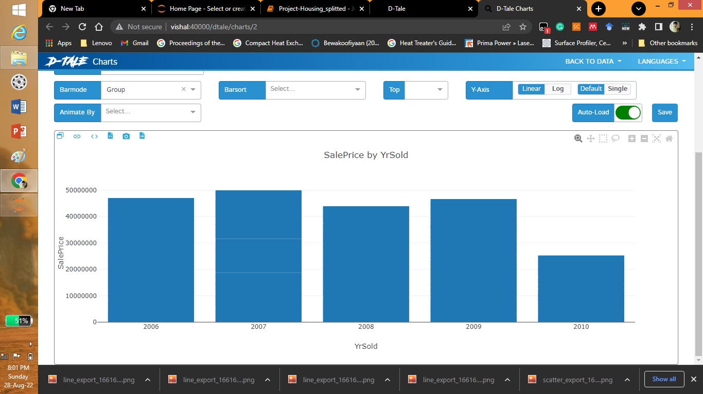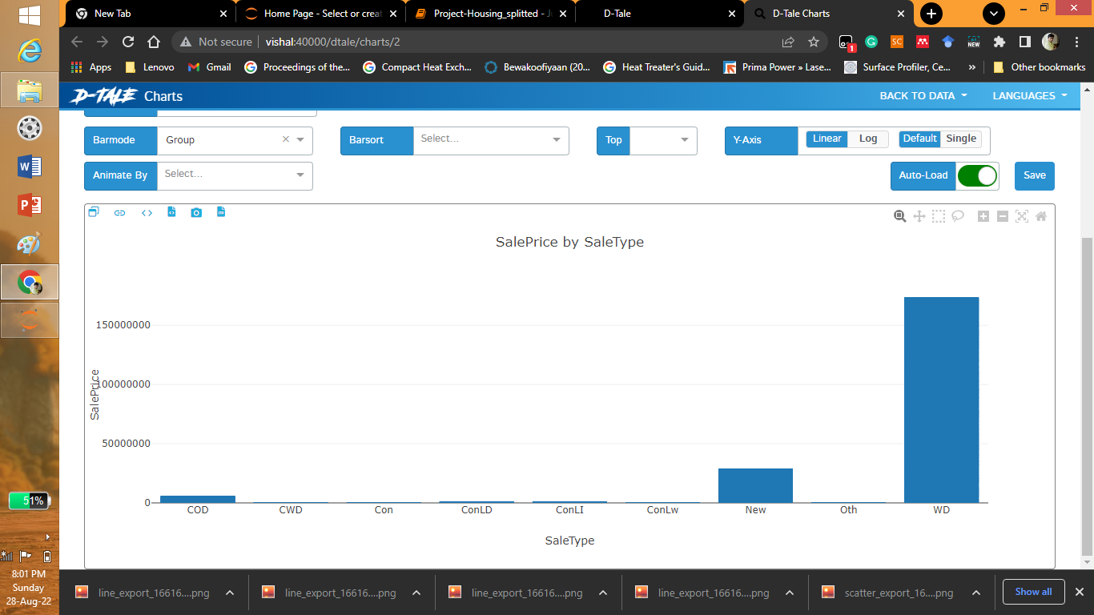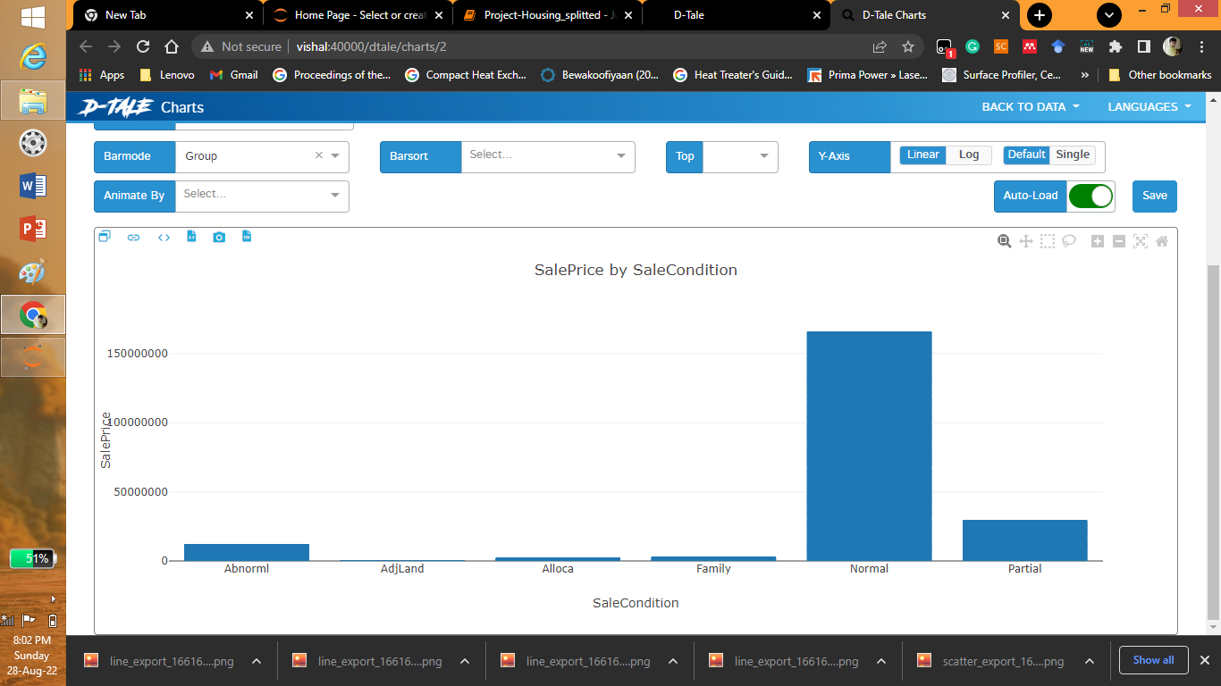

* State the set of assumptions (if any) related to the problem under consideration

Here, you can describe any presumptions taken by you.

Answer: The columns having more than 50% NAN values have been neglected.



* Hardware and Software Requirements and Tools Used

Listing down the hardware and software requirements along with the tools, libraries and packages used. Describe all the software tools used along with a detailed description of tasks done with those tools.

The different libraries and packages used are:

1. Pandas, 2. Numpy, 3. Matplotlib, 4. Sklearn and 5.Dtale etc.

Pandas: for importing the dataset

Matplotlib and Dtale: For graphing

Sklearn: Modelling

**Model/s Development and Evaluation**

* Identification of possible problem-solving approaches (methods)

Describe the approaches you followed, both statistical and analytical, for solving of this problem.

* Testing of Identified Approaches (Algorithms)

Listing down all the algorithms used for the training and testing.

* Run and Evaluate selected models

Describe all the algorithms used along with the snapshot of their code and what were the results observed over different evaluation metrics.

* Key Metrics for success in solving problem under consideration

What were the key metrics used along with justification for using it? You may also include statistical metrics used if any.

* Visualizations

Mention all the plots made along with their pictures and what were the inferences and observations obtained from those. Describe them in detail.

If different platforms were used, mention that as well.

* Interpretation of the Results

Give a summary of what results were interpreted from the visualizations, preprocessing and modelling.

**CONCLUSION**

* Key Findings and Conclusions of the Study

Describe the key findings, inferences, observations from the whole problem.

Answer: Form the visualization we can see that different groups having like RL, Pave, Gravel in alley, level of the land, location of the property, garage location etc. decides the price of the house.

* Learning Outcomes of the Study in respect of Data Science

List down your learnings obtained about the power of visualization, data cleaning and various algorithms used. You can describe which algorithm works best in which situation and what challenges you faced while working on this project and how did you overcome that.

Answer: The 80 columns are all important when purchasing a house. The visualization by bar and line graphs of bivariate analysis gives a clear picture of different types of accessories of house to the selling price. Data cleaning is very important as the data many contain NAN and junk entries which doesn’t given any information. When 80 columns are provided the greatest challenge is to understand the column which gives picture to provide an ordinal encoding in model selection. This was the greatest challenge.

* Limitations of this work and Scope for Future Work

What are the limitations of this solution provided, the future scope? What all steps/techniques can be followed to further extend this study and improve the results.

Answer: The solution provided only has the accuracy of 82 approximately by using neural networks this accuracy can be increased